**SMS SQL Assignment**

**Name:**

**Note: Read the following carefully**

* Any late submission will be considered as a grade of 0%

### Only Two submissions are allowed. (one for sql query and one for this report)

### I do not accept your report or sql query through email.

### Only one person on be half of the group submit the code and report

### Note : Make sure you provide the screen shots below each question

### Whoever is uploading the assignment needs to fill the following tables

### The following students have participated in the assignment

|  |
| --- |
| Student Name |
| Ali Ibrahim - 200469690 |
| Fatih Bugra Sagiroglu-200469929 |
| Princess Uchegbulam - 200474583 |
| Sahil Arora - 200470998 |
| Alihan Karaoglu - 200471956 |
| Tricia McIntosh – 200434993 |

### The following students have not participated in the assignment

|  |
| --- |
| Student Name |
| All Participated |

**Mini project – Student Data Management**

1. Create a database called “LMT_University”.

--1.Create a database called “LMT_University”.

create database LMT_University;

1. Create an “enrol” schema under “LMT_University”.

--2. Create an “enrol” schema under “LMT_University”.

use LMT_University

go

1. Use “enrol” Schema for creating the project.

--3. Use “enrol” Schema for creating the project.

create schema enrol

go

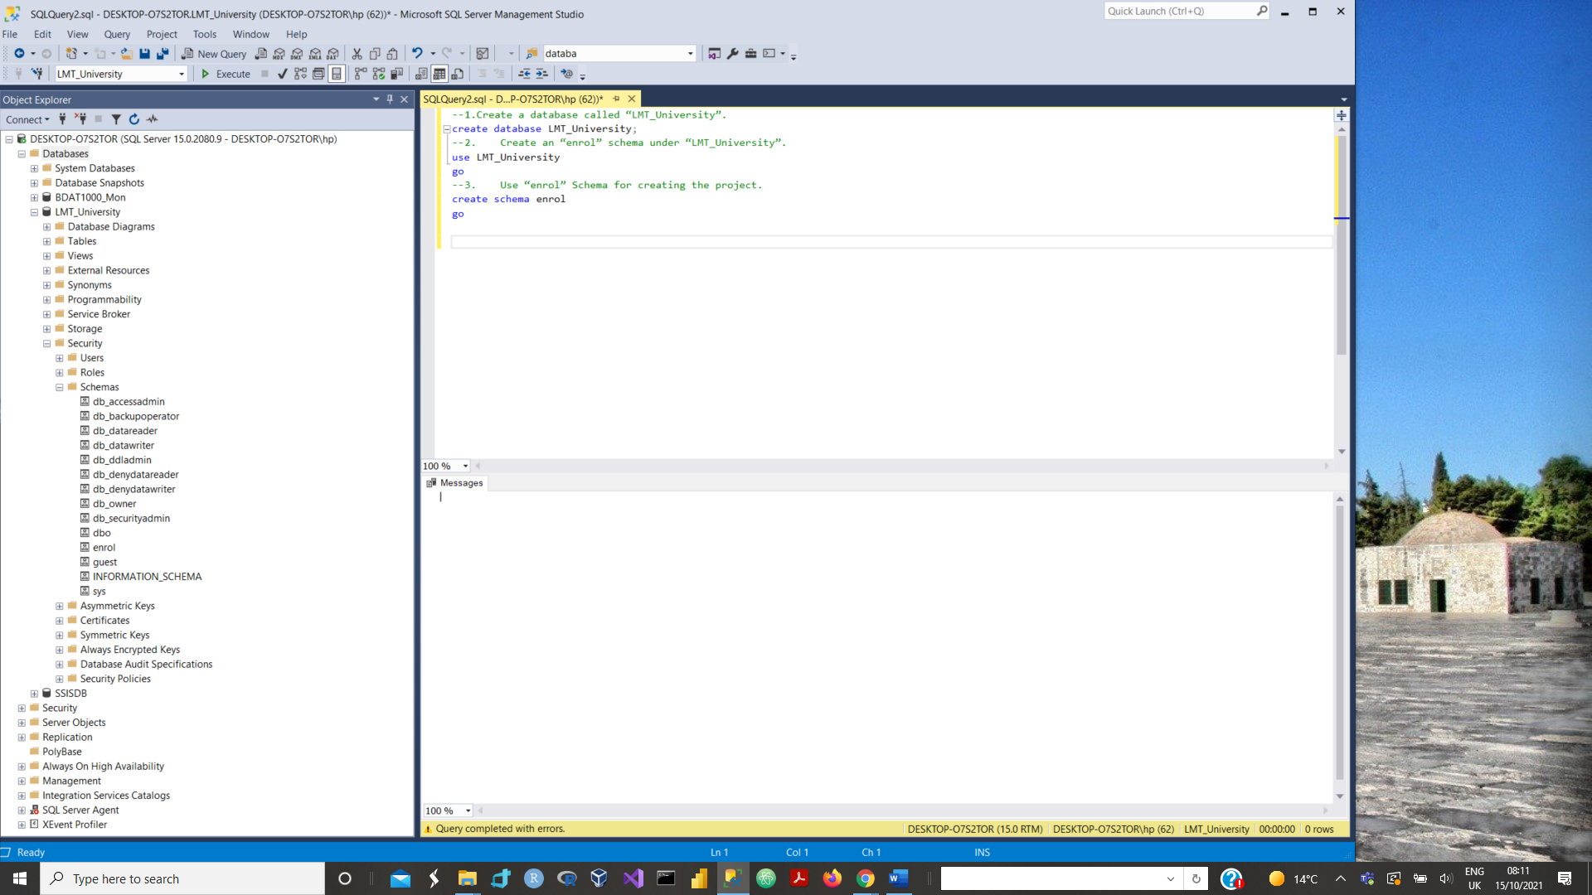

1. Create the Database modeling in such a way that Model looks like-

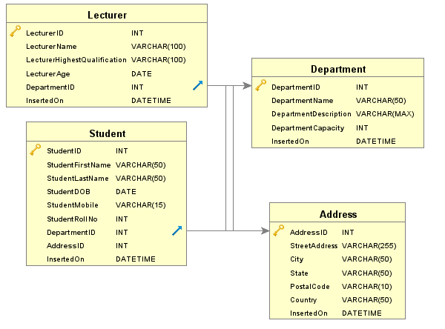

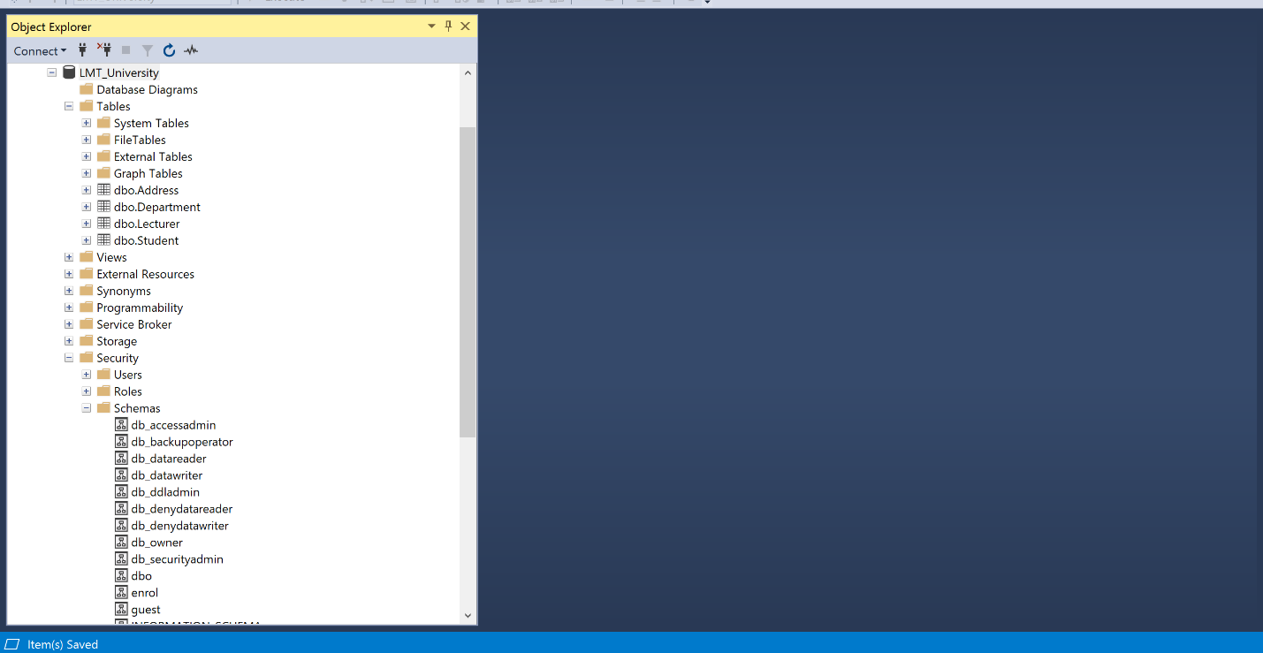

1. Create an “Address” table under “enrol” schema with the following specifications-
   1. Address table must have the following attributes-

|  |  |  |
| --- | --- | --- |
| **Column Name** | **Data Type** | **Description** |
| AddressID | Integer | Address Unique Identifier |
| StreetAddress | Varchar | Street Address |
| City | Varchar | City |
| State | Varchar | State |
| PostalCode | Varchar | Zip Code of a particular location |
| Country | Varchar | Country |
| InsertedOn | DateTime | Data Insertion Date |

* 1. Add the following constraint.
     1. AddressID: Auto Increment, Primary Key, Not null, clustered index.
     2. StreetAddress: Null
     3. City: Not Null
     4. State: Null
     5. PostalCode: Null
     6. Country: Not Null
     7. InsertedOn: Not Null

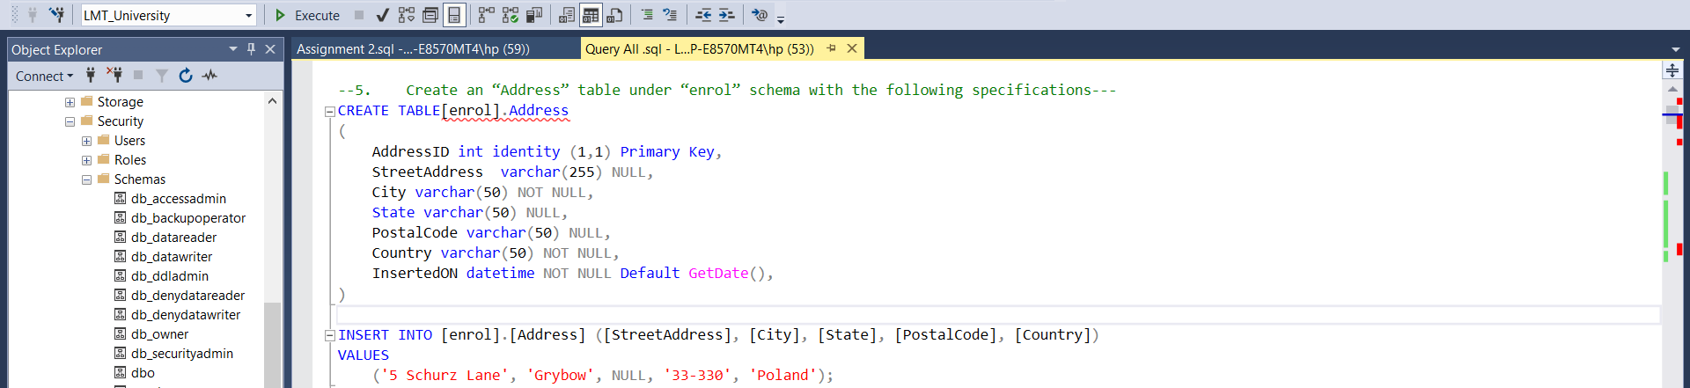

* 1. Insert the following records based on the following specifications.
     1. AddressID: Address ID starting from 1 to 30 with step size 1.
     2. StreetAddress: Insert the street Address mentioned in the table.
     3. City: Insert the City mentioned in the table.
     4. State: Insert the State mentioned in the table.
     5. PostalCode: Insert the PostalCode mentioned in the table.
     6. Country: Insert the Country mentioned in the table.
     7. InsertedOn: Insert as default date as system date.

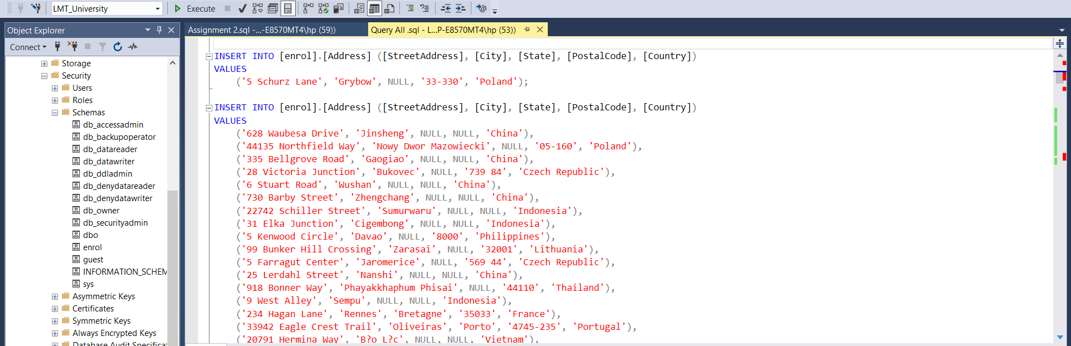

* 1. After Insertion, Table looks like as shown below-

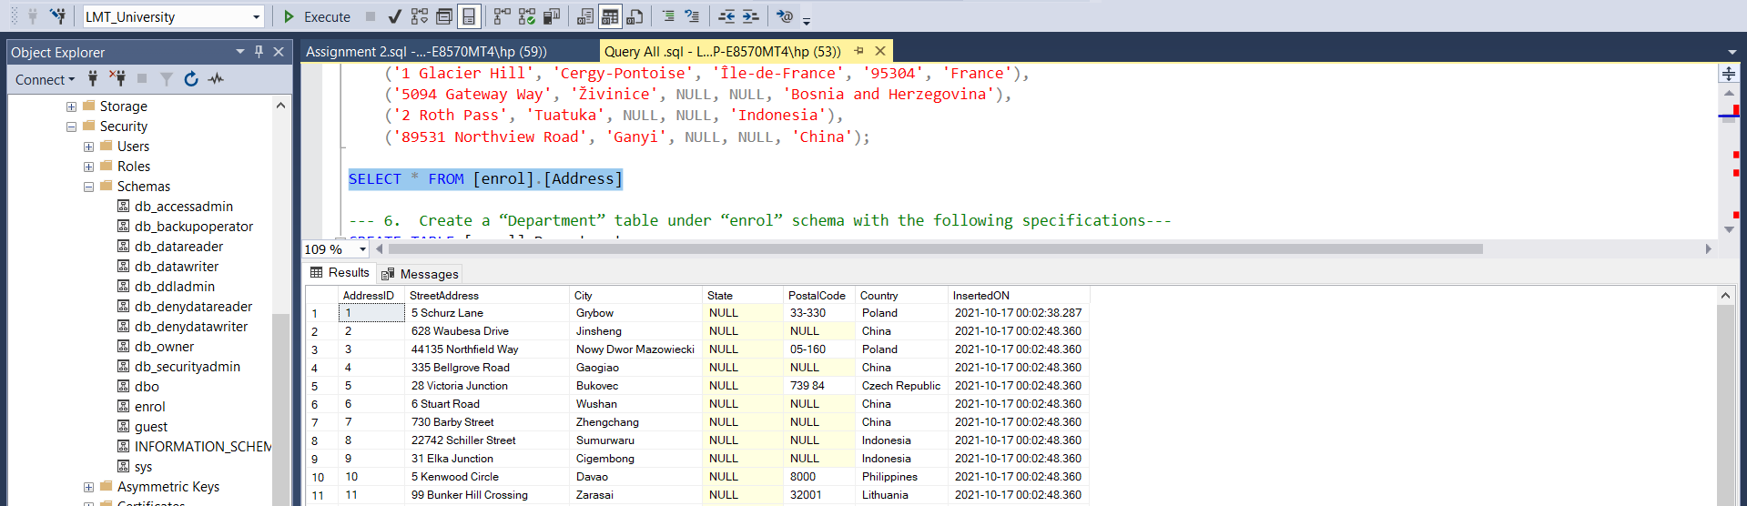

1. Create a “Department” table under “enrol” schema with the following specifications-
   1. Department table Must have the following attributes-

|  |  |  |
| --- | --- | --- |
| **Column Name** | **Data Type** | **Description** |
| DepartmentID | Integer | Department Unique Identifier |
| DepartmentName | Lecturer | Department Name |
| DepartmentDescription | Varchar | Department Description |
| DepartmentCapacity | Integer | Department Maximum Occupancy |
| InsertedOn | DateTime | Data Insertion Date |

* 1. Add the following constraints-
     1. DepartmentID: Auto Increment, Primary Key, Not null, clustered index.
     2. DepartmentName: Not Null
     3. DepartmentDescription: Null
     4. DepartmentCapacity: Not Null
     5. InsertedOn: Not Null
  2. Insert the following records based on the following specifications.
     1. DepartmentID: Department ID starting from 1 to 30 with step size 1.
     2. DepartmentName: Insert the Department Name mentioned in the table.
     3. DepartmentDescription: Insert the Department Description mentioned in the table.
     4. DepartmentCapacity: Insert the Department Capacity mentioned in the table.
     5. InsertedOn: Insert as default date as system date.
  3. After Insertion, Table looks like as shown below-

**Answer:**

**6.a/b**

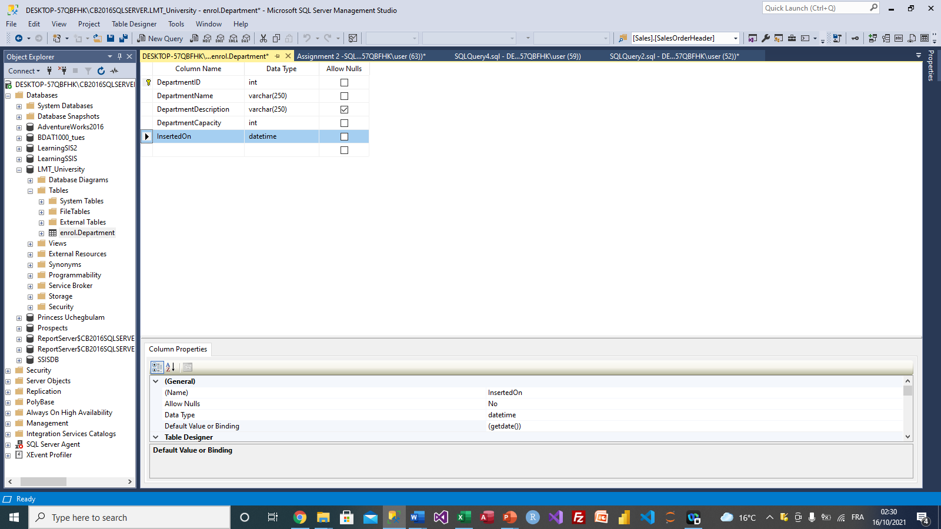

**6c.**

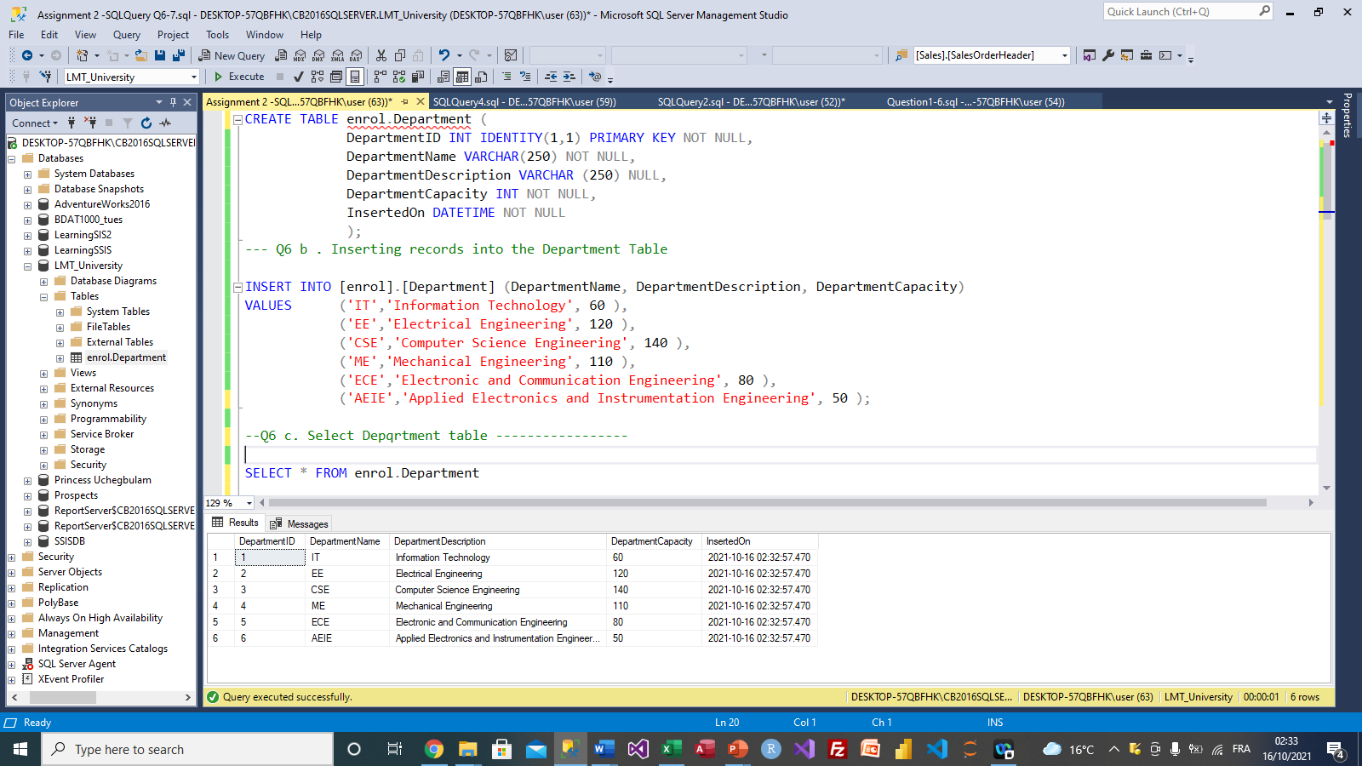

1. Create a “Lecturer” table under “enrol” schema with the following specifications-
   1. Lecturer table Must have the following attributes-

|  |  |  |
| --- | --- | --- |
| **Column Name** | **Data Type** | **Description** |
| LecturerID | Integer | Lecturer Unique Identifier |
| LecturerName | Varchar | Lecturer Name |
| LecturerHighestQualification | Varchar | Lecturer Highest Qualification |
| LecturerAge | Varchar | Lecturer Joining Date |
| DepartmentID | Integer | Department Unique Identifier |
| InsertedOn | DateTime | Data Insertion Date |

* 1. Add the following constraints-
     1. LecturerID: Auto Increment, Primary Key, Not null, clustered index.
     2. LecturerName: Not Null
     3. LecturerHighestQualification: Null
     4. LecturerAge: Not Null
     5. DepartmentID: Not Null
     6. InsertedOn: Null
  2. Insert the following records based on the following specifications.
     1. LecturerID: Lecturer ID starting from 1 to 30 with step size 1.
     2. LecturerName: Insert the Lecturer Name mentioned in the table.
     3. LecturerHighestQualification: Insert the Lecturer Highest Qualification mentioned in the table.
     4. LecturerAge: Insert the Lecturer Age mentioned in the table.
     5. DepartmentID: Foreign key, Not Null.
     6. InsertedOn: Insert as default date as system date.
  3. After Insertion, Table looks like as shown below-

**Answer:**

**7a. Create a “Lecturer” table under “enrol” schema**

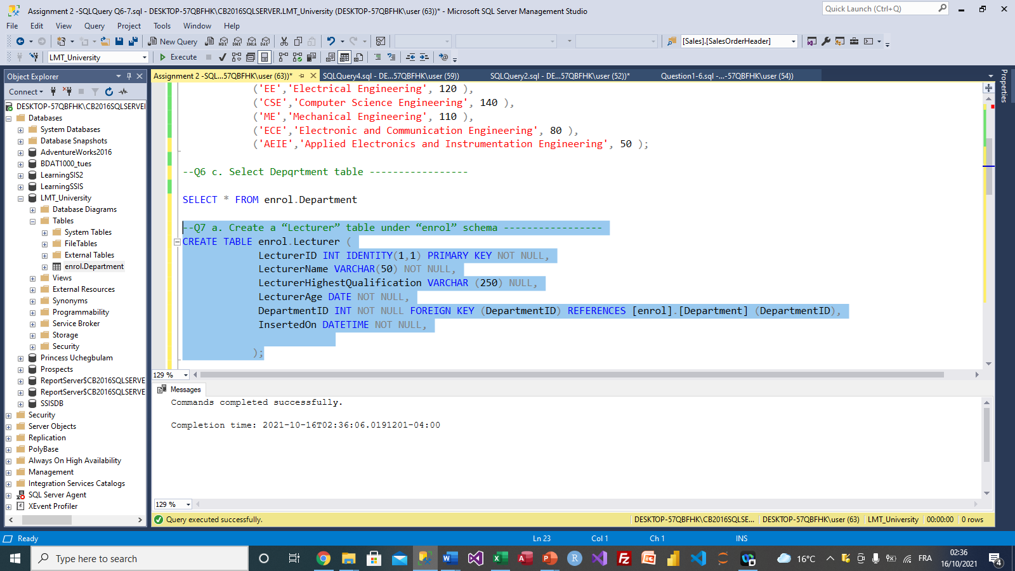

**7b. Add the following constraints**

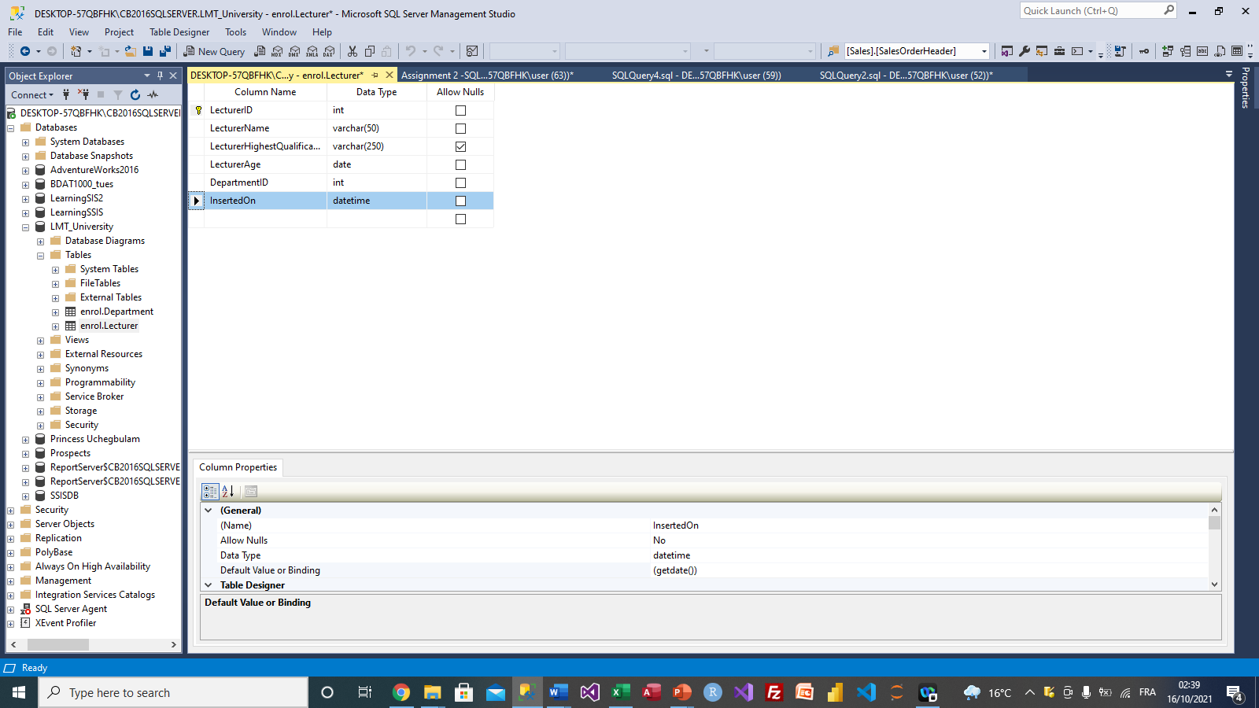

**7c. Insert records**

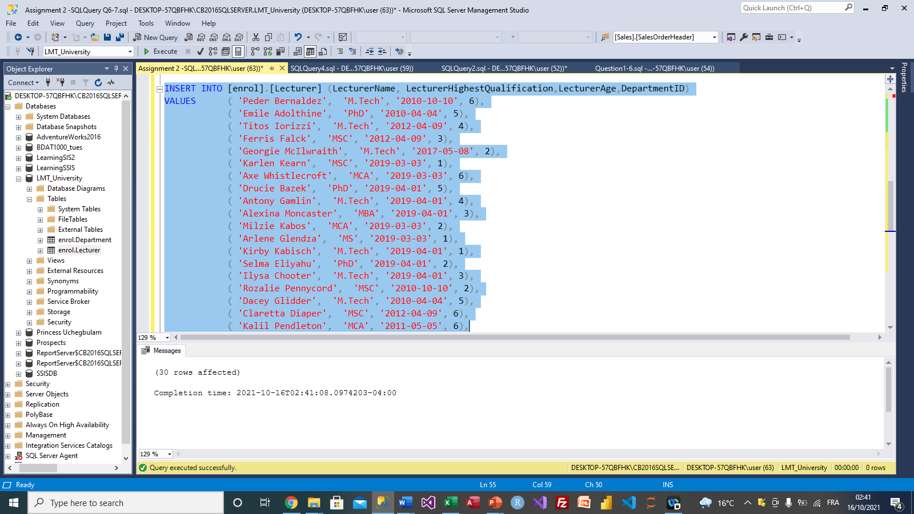

**7d. Select Table Lecturer**

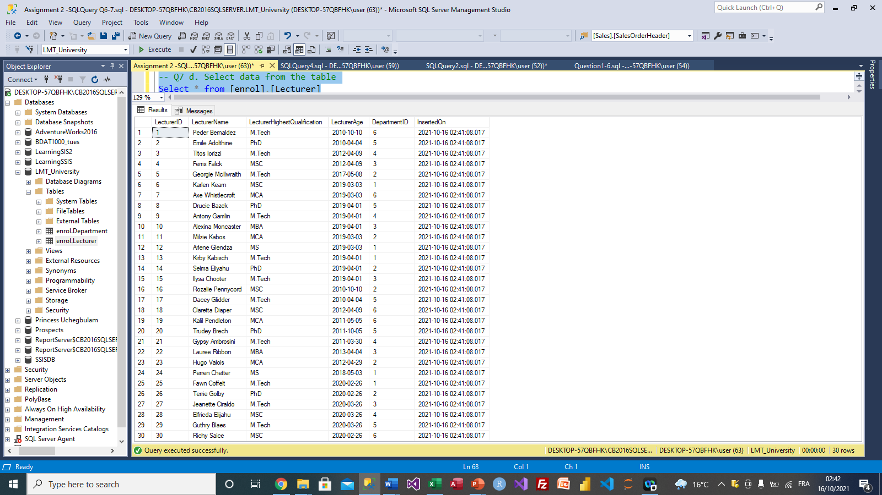

1. Create a “Student” table under “enrol” schema with the following specifications-
   1. Student table Must have the following attributes-

|  |  |  |
| --- | --- | --- |
| **Column Name** | **Data Type** | **Description** |
| StudentID | Integer | Student Unique Identifier |
| StudentFirstName | Varchar | Student First Name |
| StudentLastName | Varchar | Student Last Name |
| StudentDOB | Date | Student Date of Birth |
| StudentMobile | Varchar | Department Unique Identifier |
| StudentRollNo | Integer | Student Roll Number |
| DepartmentID | Integer | Department Unique Identifier |
| AddressID | Integer | Address Unique Identifier |
| InsertedOn | DateTime | Data Insertion Date |

* 1. Add the following constraints-
     1. StudentID: Auto Increment, Primary Key, Not null, clustered index.
     2. StudentFirstName: Not Null
     3. StudentLastName: Null
     4. StudentDOB: Not Null
     5. StudentMobile: Null
     6. StudentRollNo: Not Null
     7. DepartmentID: Foreign key, Not Null.
     8. AddressID: Foreign key, Not Null.
     9. InsertedOn: Not Null

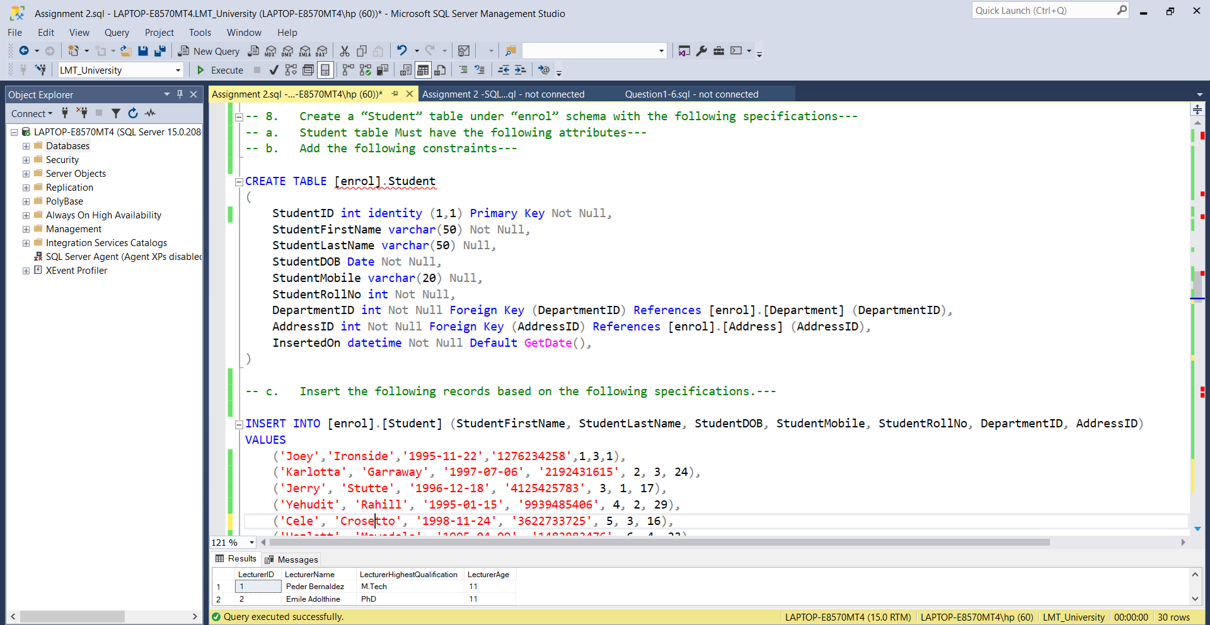

1. Insert the following records based on the following specifications.
   * 1. StudentID: Student ID starting from 1 to 50 with step size 1.
     2. StudentFirstName: Insert the Student First Name mentioned in the table.
     3. StudentLastName: Insert the Student Last Name mentioned in the table.
     4. StudentDOB: Insert the Student DOB mentioned in the table.
     5. StudentMobile: Insert the Student Mobile no mentioned in the table.
     6. StudentRollNo: Insert the Student Roll no mentioned in the table.
     7. DepartmentID: Insert the Department ID mentioned in the table.
     8. AddressID: Insert the Address ID mentioned in the table.
     9. InsertedOn: Insert as default date as system date.

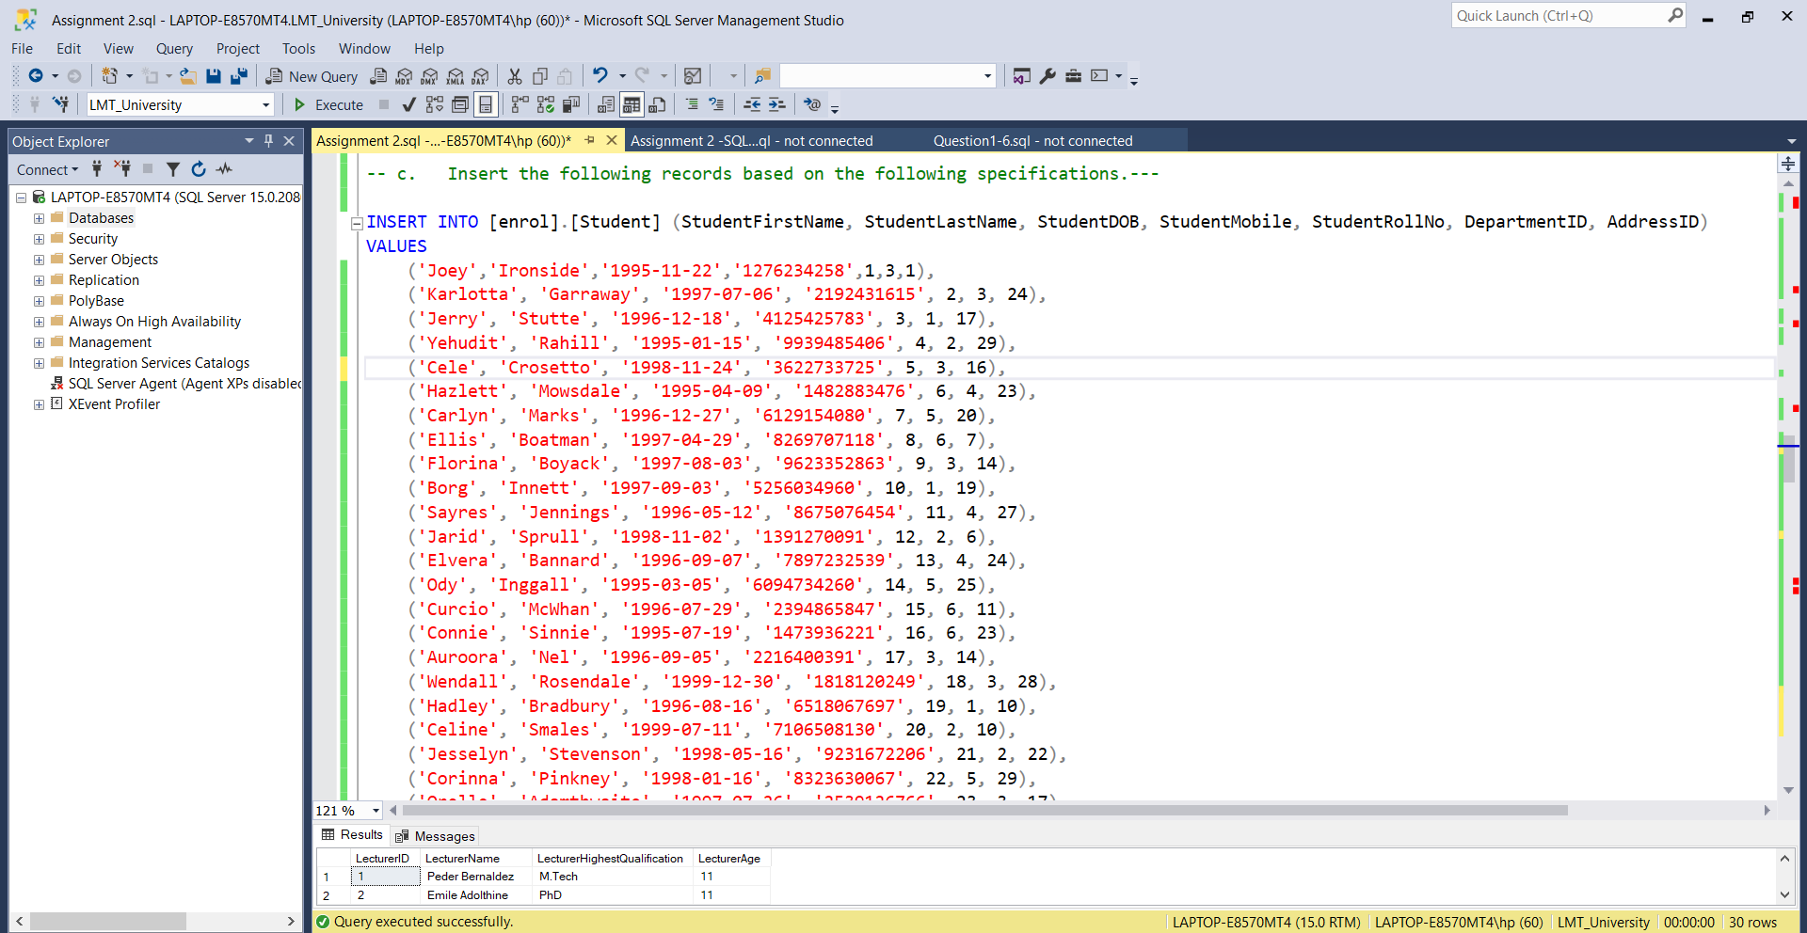

1. **After Insertion, Table looks like as shown below-**

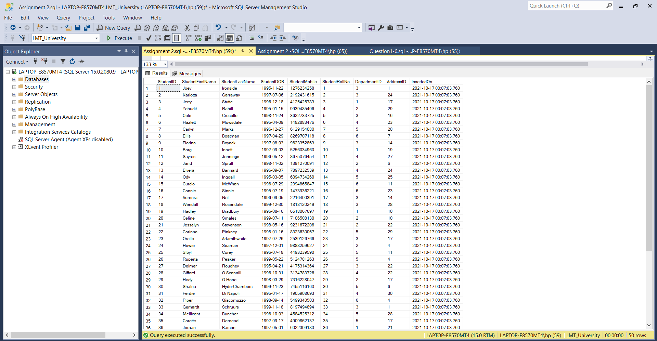

1. **Write the following Query based on the above datasets.**
   1. **List all the Student information from the Student table.**

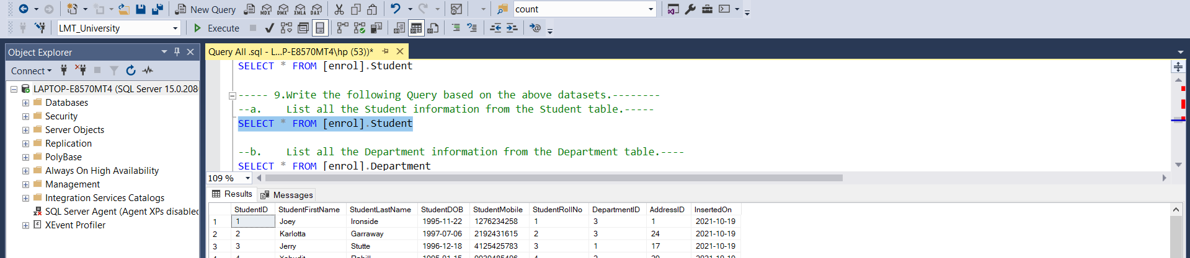

* 1. **List all the Department information from the Department table.**

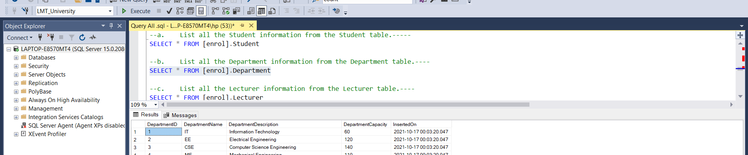

* 1. **List all the Lecturer information from the Lecturer table.**

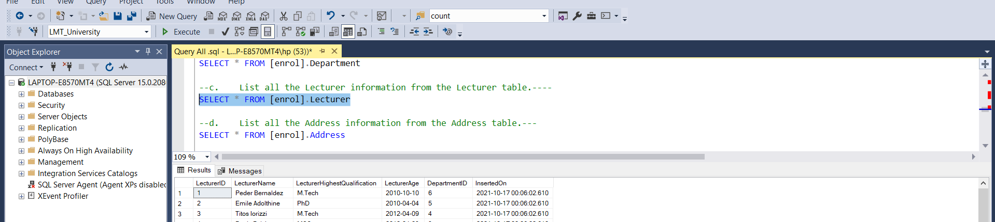

* 1. **List all the Address information from the Address table.**

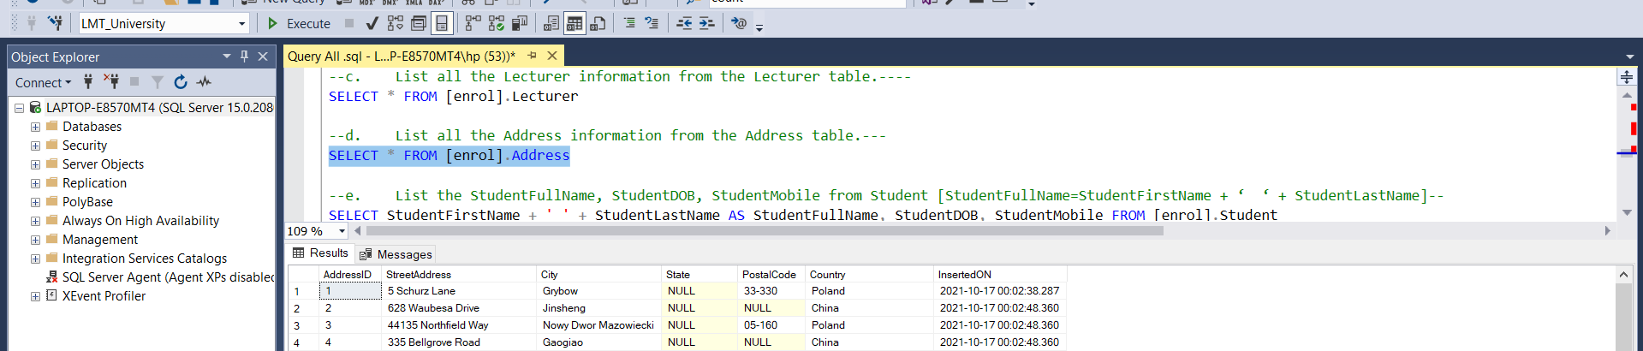

* 1. **List the StudentFullName, StudentDOB, StudentMobile from Student [StudentFullName=StudentFirstName + ‘ ‘ + StudentLastName]**

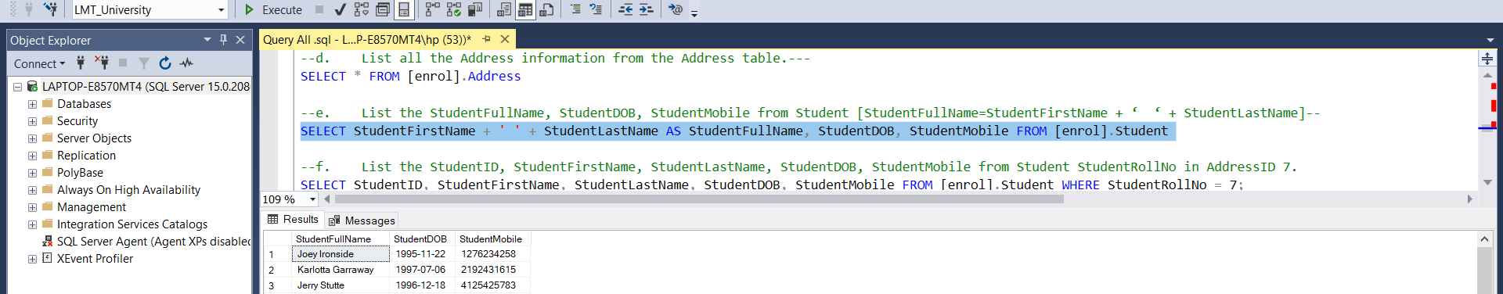

* 1. **List the StudentID, StudentFirstName, StudentLastName, StudentDOB, StudentMobile from Student StudentRollNo in AddressID 7.**

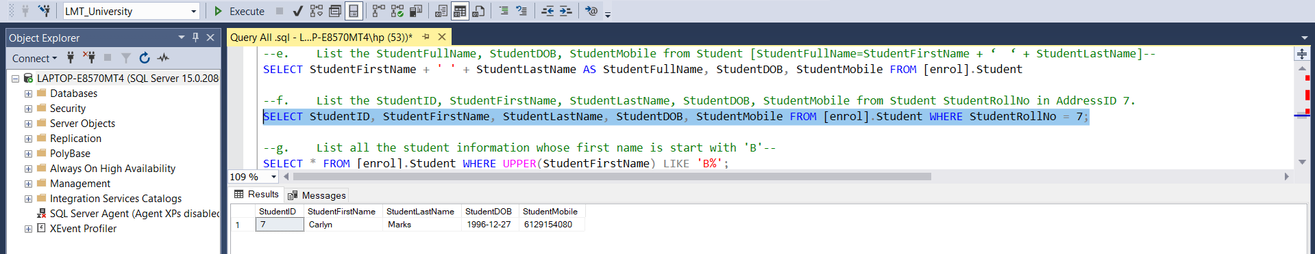

* 1. **List all the student information whose first name is start with 'B'**

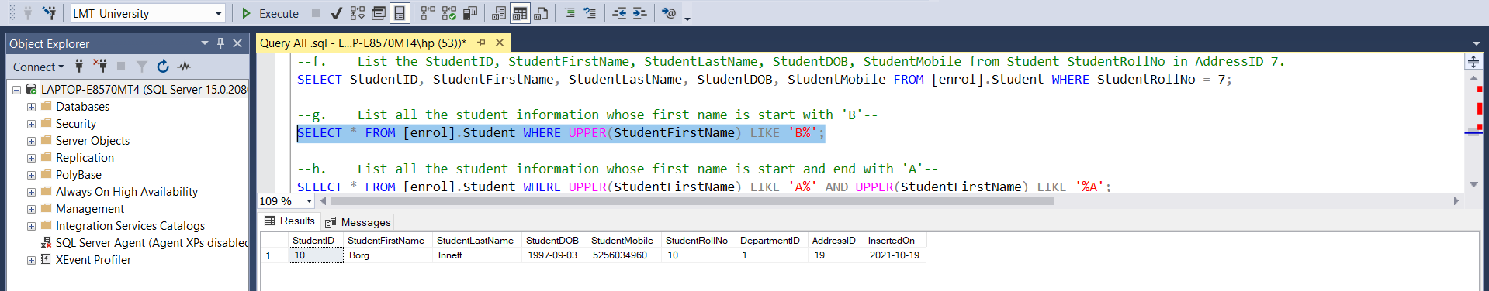

* 1. **List all the student information whose first name is start and end with 'A'**

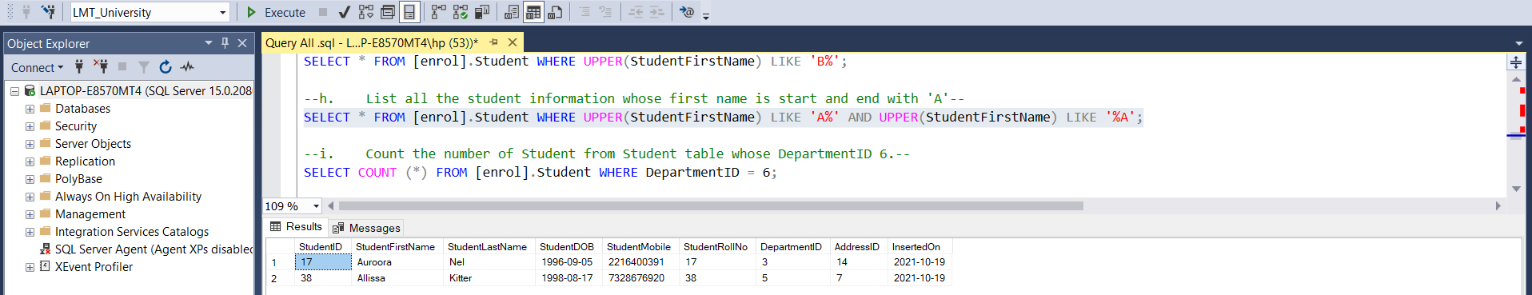

* 1. **Count the number of Student from Student table whose DepartmentID 6.**

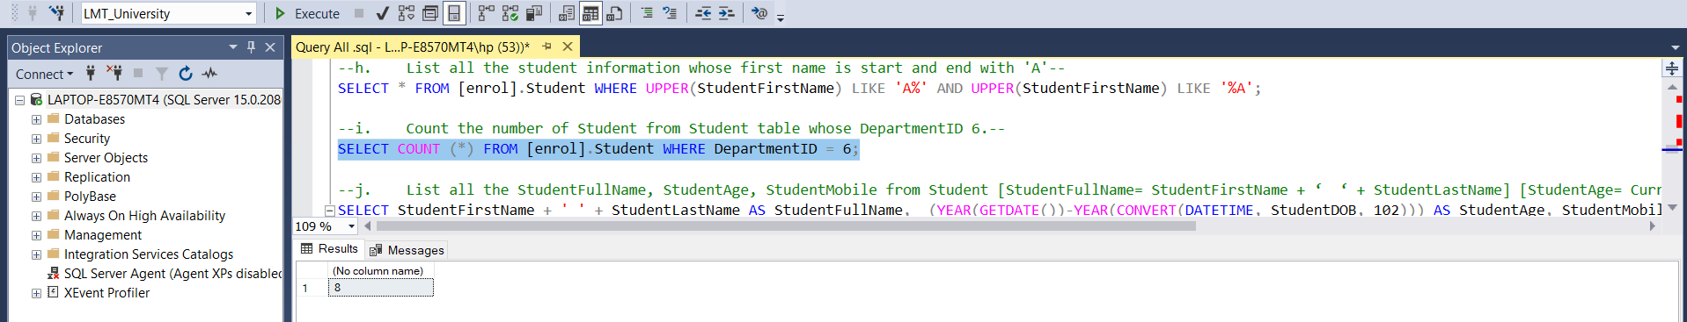

* 1. **List all the StudentFullName, StudentAge, StudentMobile from Student [StudentFullName= StudentFirstName + ‘ ‘ + StudentLastName]**

**[StudentAge= Current date – DOB (in Years)]**

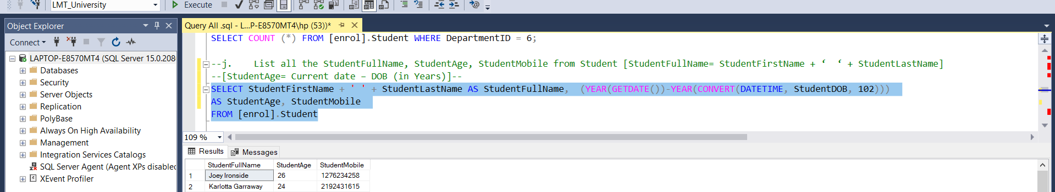

* 1. **List all the StudentFullName, StudentAge, StudentMobile whose Age>23 from Student [StudentFullName= StudentFirstName + ‘ ‘ + StudentLastName]**

**[StudentAge= Current date – DOB (in Years)]**

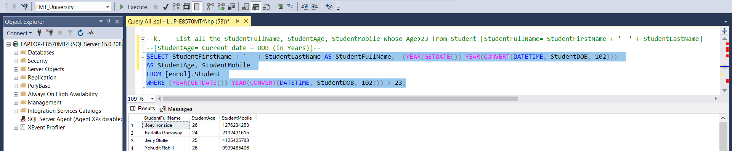

* 1. **List all the StudentFullName, StudentAge, StudentMobile whose Age is either 21 or 23 from Student [StudentFullName= StudentFirstName + ‘ ‘ + StudentLastName]**

**[StudentAge= Current date – DOB (in Years)]**

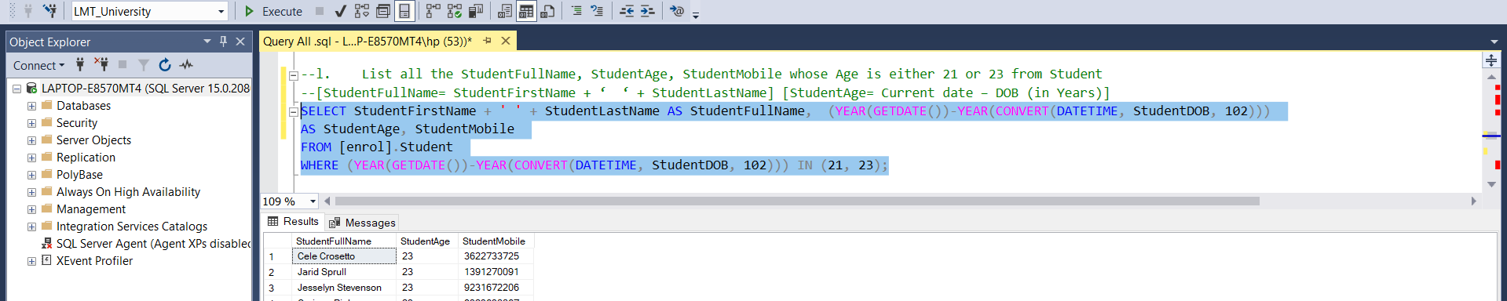

* 1. **List all the LecturerID, LecturerName, LecturerHighestQualification, LecturerAge from Lecturer.**

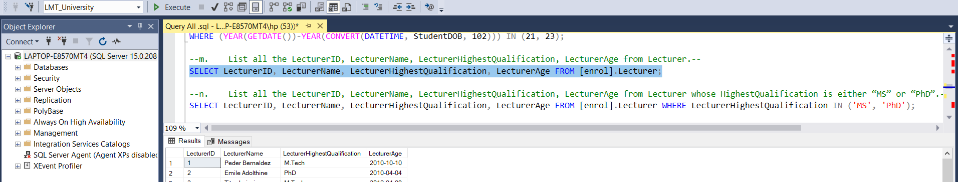

* 1. **List all the LecturerID, LecturerName, LecturerHighestQualification, LecturerAge from Lecturer whose HighestQualification is either “MS” or “PhD”.**

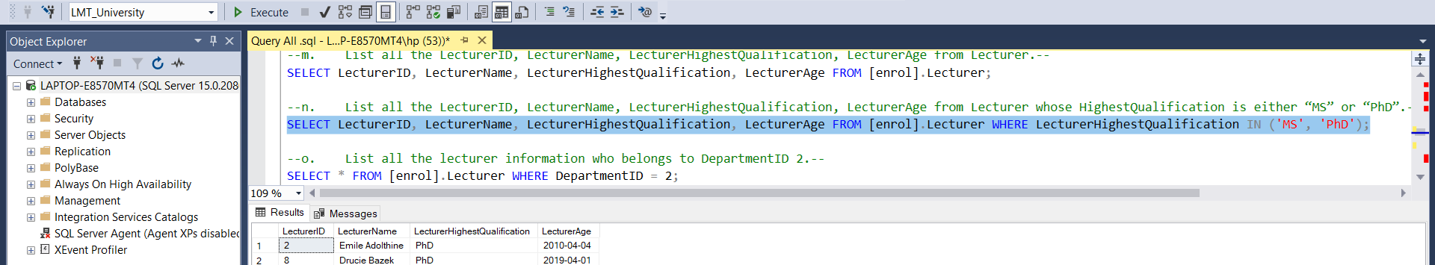

* 1. **List all the lecturer information who belongs to DepartmentID 2.**

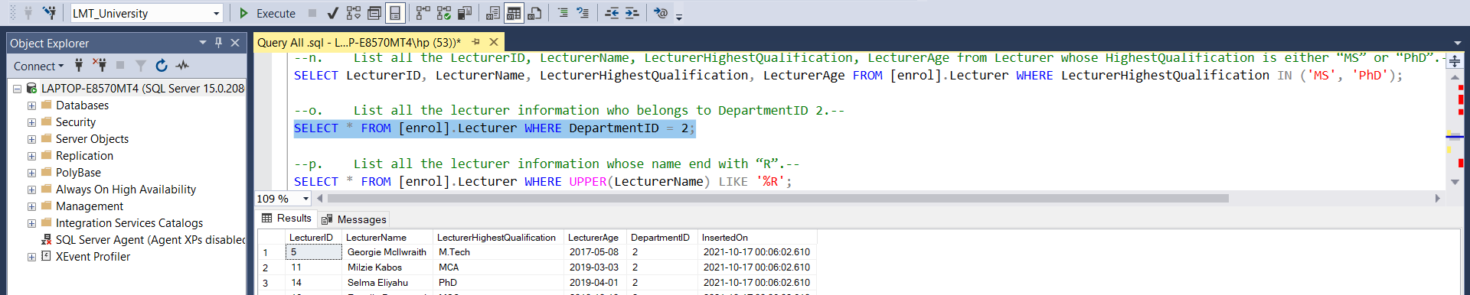

* 1. **List all the lecturer information whose name end with “R”.**

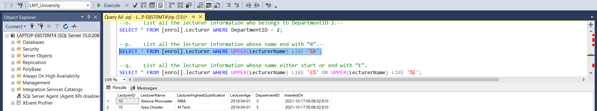

* 1. **List all the lecturer information whose name either start or end with “E”.**

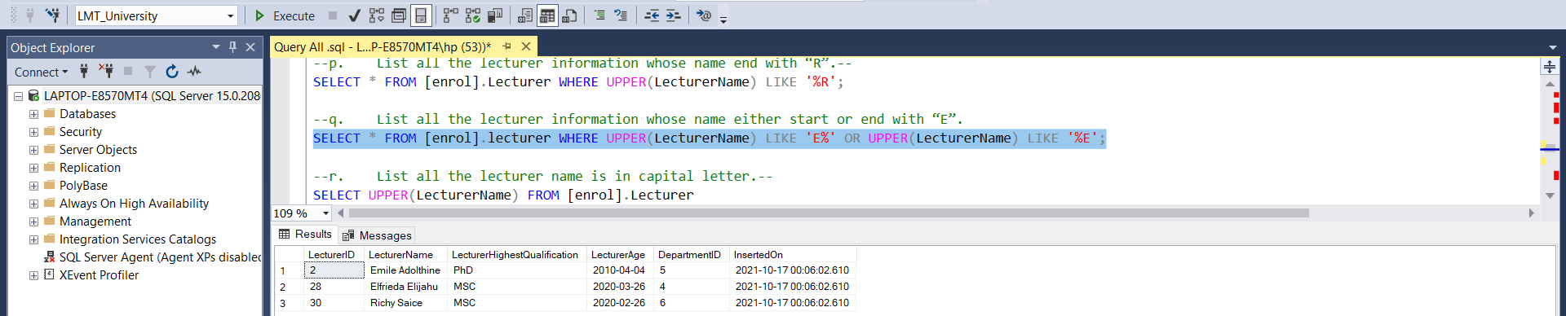

* 1. **List all the lecturer name is in capital letter.**

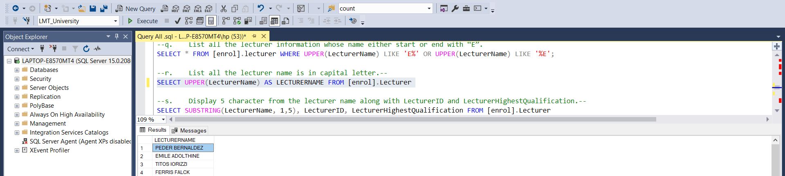

* 1. **Display 5 character from the lecturer name along with LecturerID and LecturerHighestQualification.**

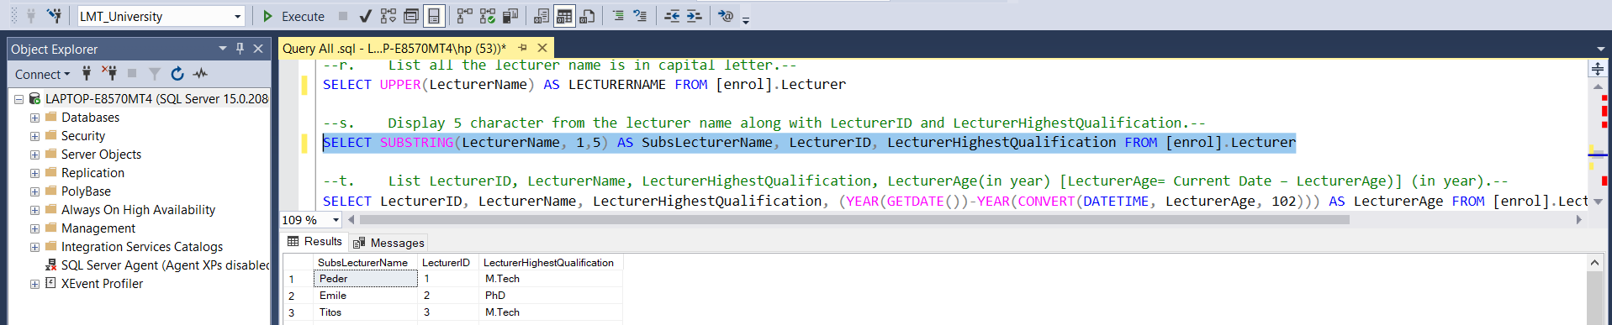

* 1. **List LecturerID, LecturerName, LecturerHighestQualification, LecturerAge(in year) [LecturerAge= Current Date – LecturerAge)] (in year).**

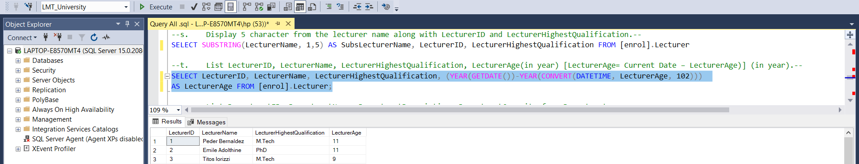

* 1. **List DepartmentID, DepartmentName, DepartmentDescription, DepartmentCapacity from Department.**

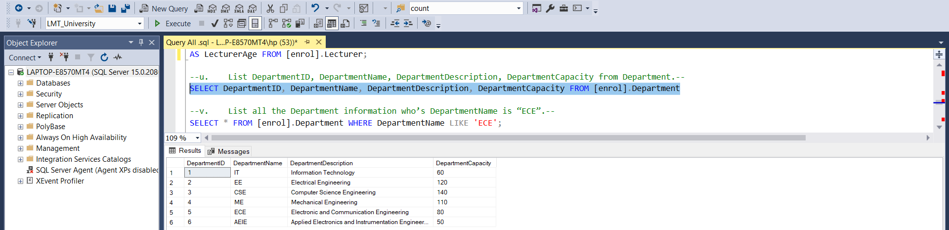

* 1. **List all the Department information who’s DepartmentName is “ECE”.**

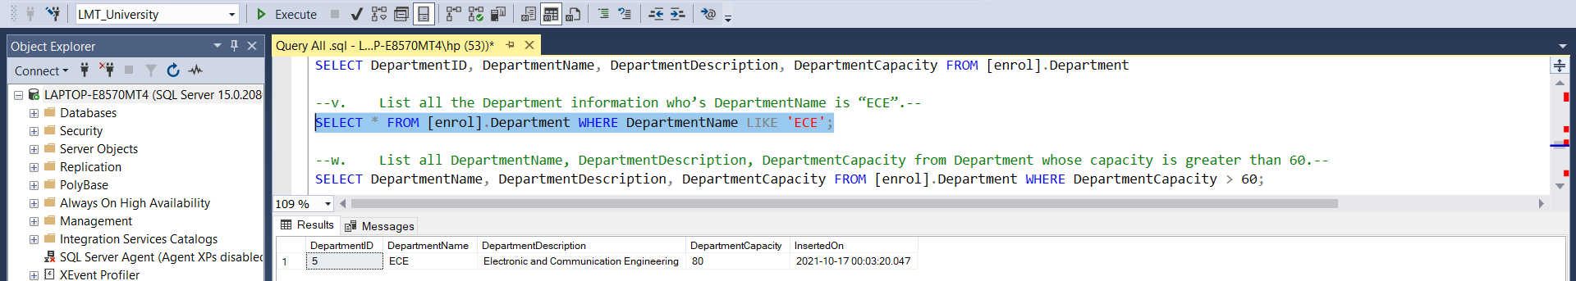

* 1. **List all DepartmentName, DepartmentDescription, DepartmentCapacity from Department whose capacity is greater than 60.**

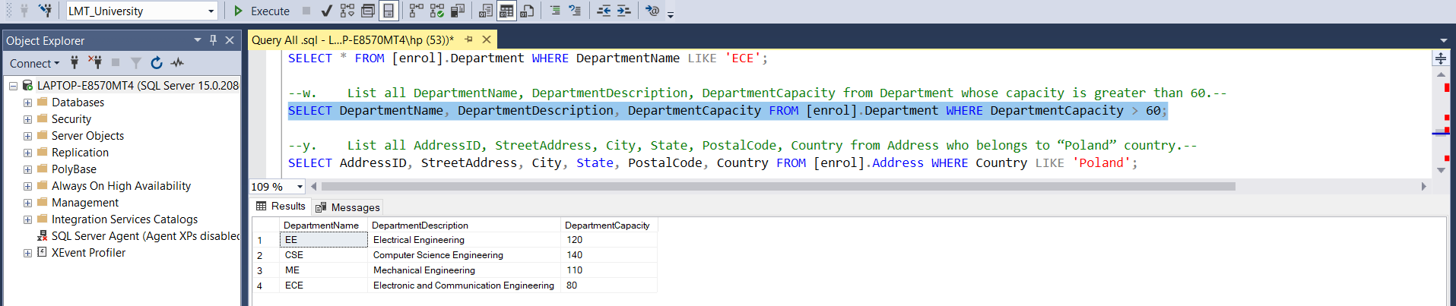

* 1. **List all AddressID, StreetAddress, City, State, PostalCode, Country from Address.**

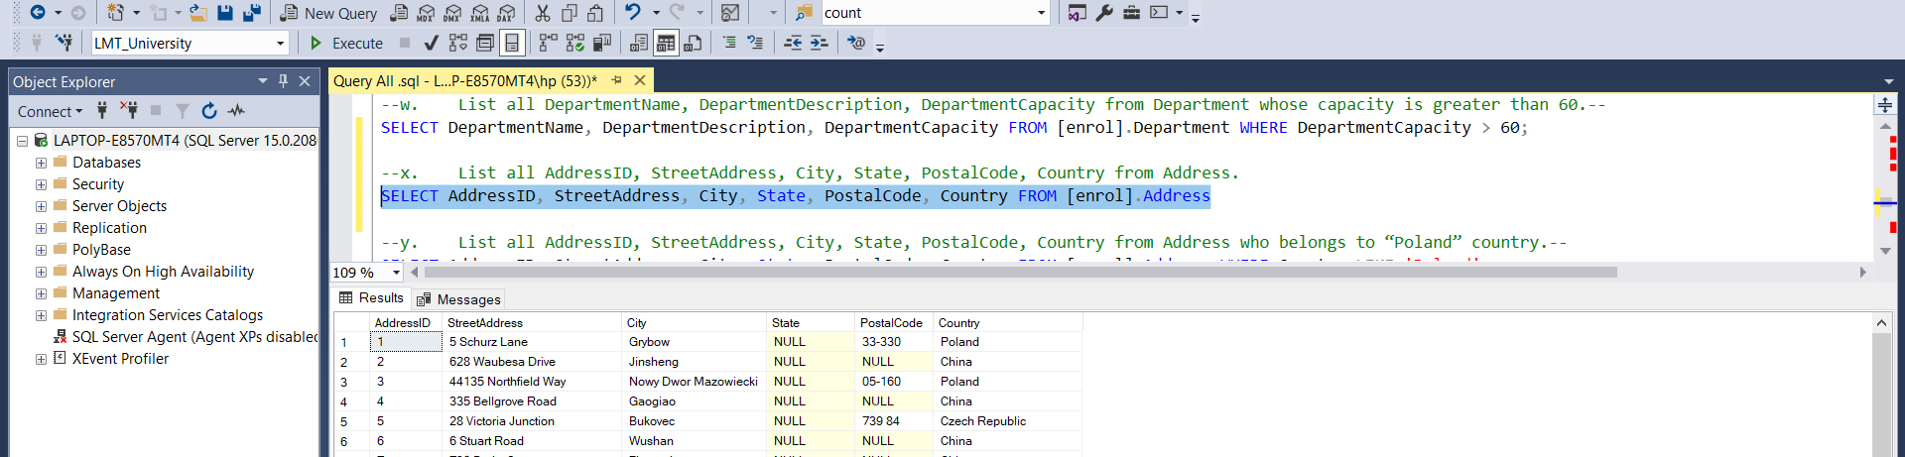

* 1. **List all AddressID, StreetAddress, City, State, PostalCode, Country from Address who belongs to “Poland” country.**

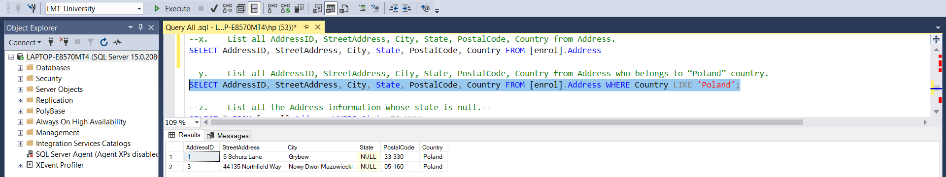

* 1. **List all the Address information whose state is null.**

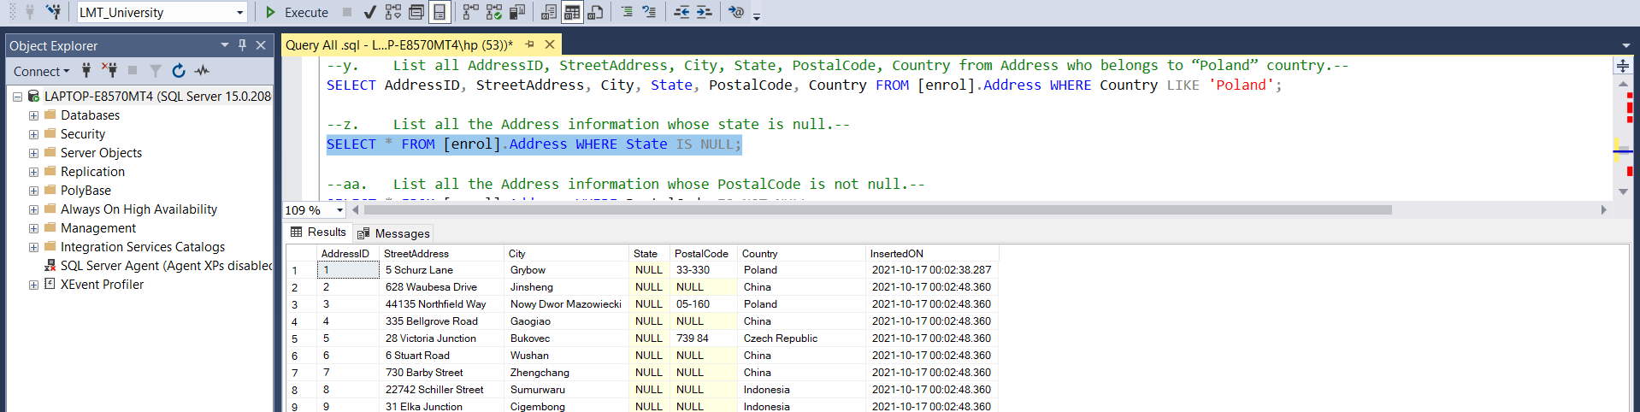

* 1. **List all the Address information whose PostalCode is not null.**

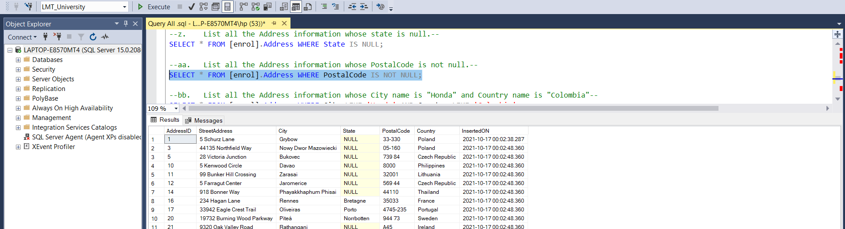

* 1. **List all the Address information whose City name is "Honda" and Country name is "Colombia"**

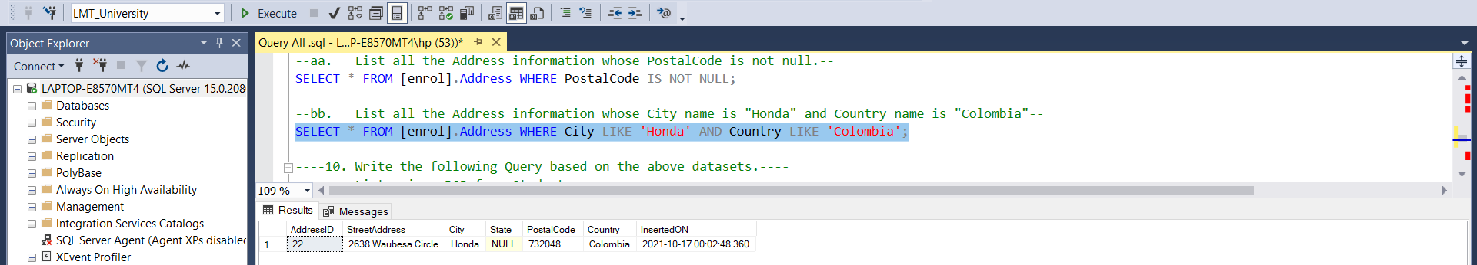

1. **Write the following Query based on the above datasets.**
   1. **List unique DOB from Student.**

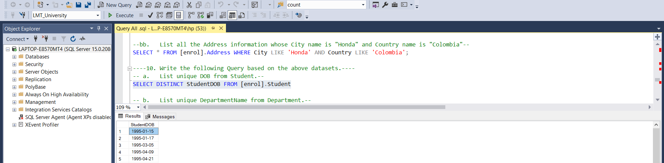

* 1. **List unique DepartmentName from Department.**

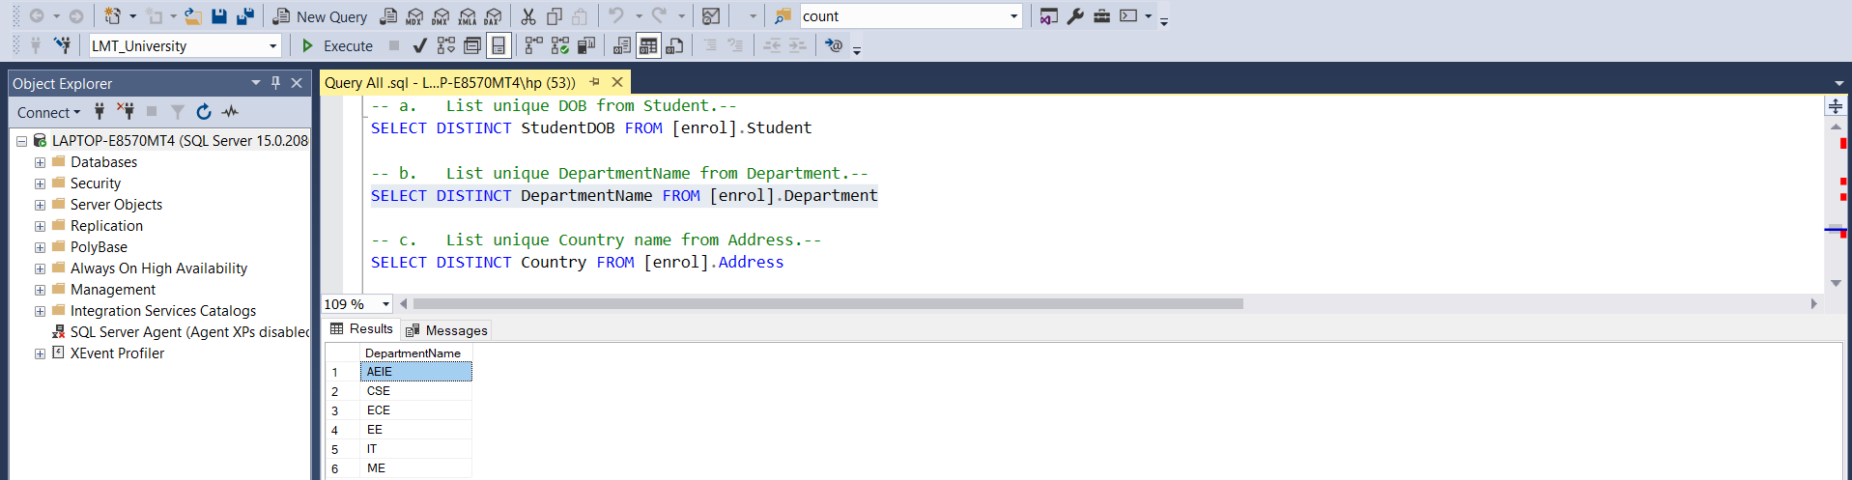

* 1. **List unique Country name from Address.**

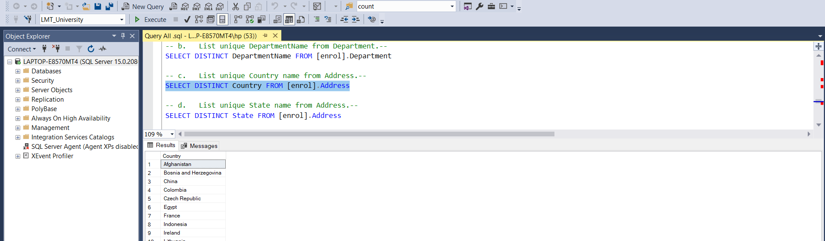

* 1. **List unique State name from Address.**

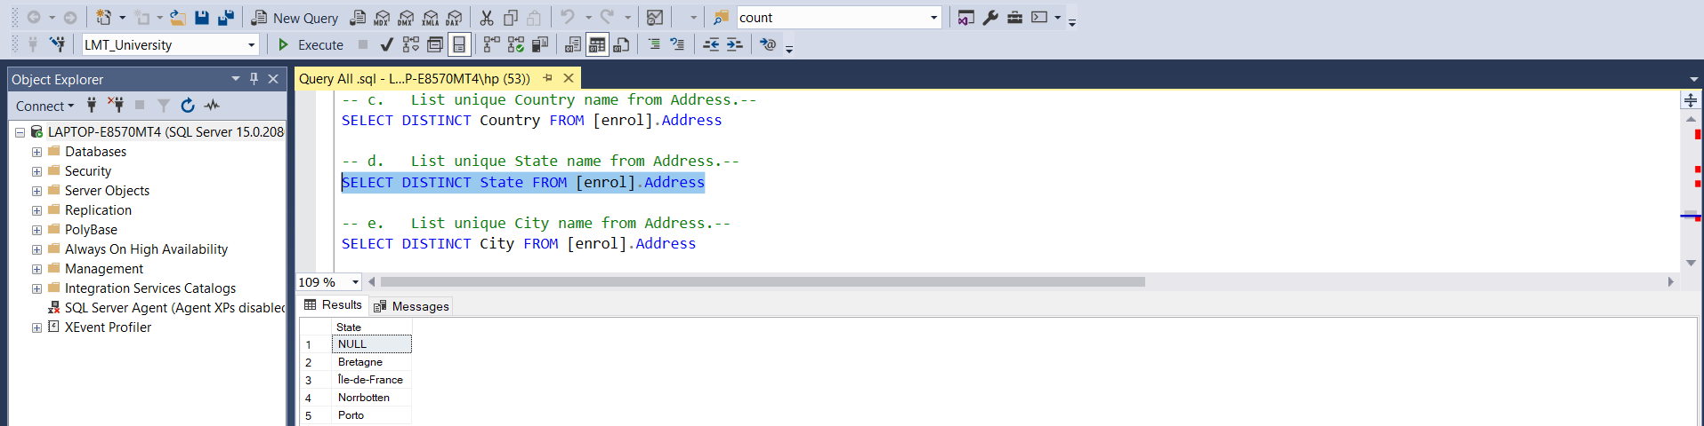

* 1. **List unique City name from Address.**

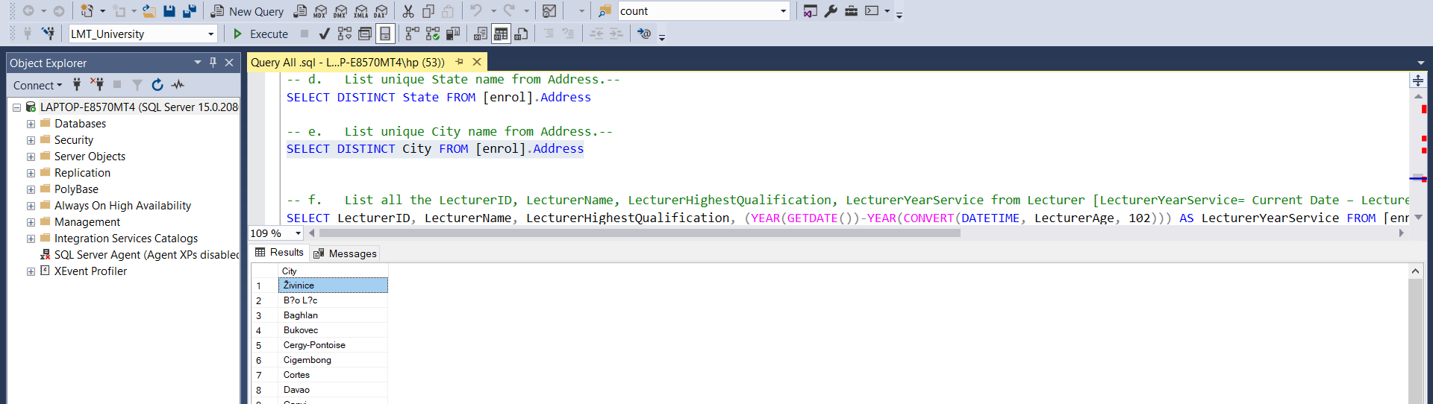

* 1. **List all the LecturerID, LecturerName, LecturerHighestQualification, LecturerYearService from Lecturer [LecturerYearService= Current Date – LecturerAge] (in year).**

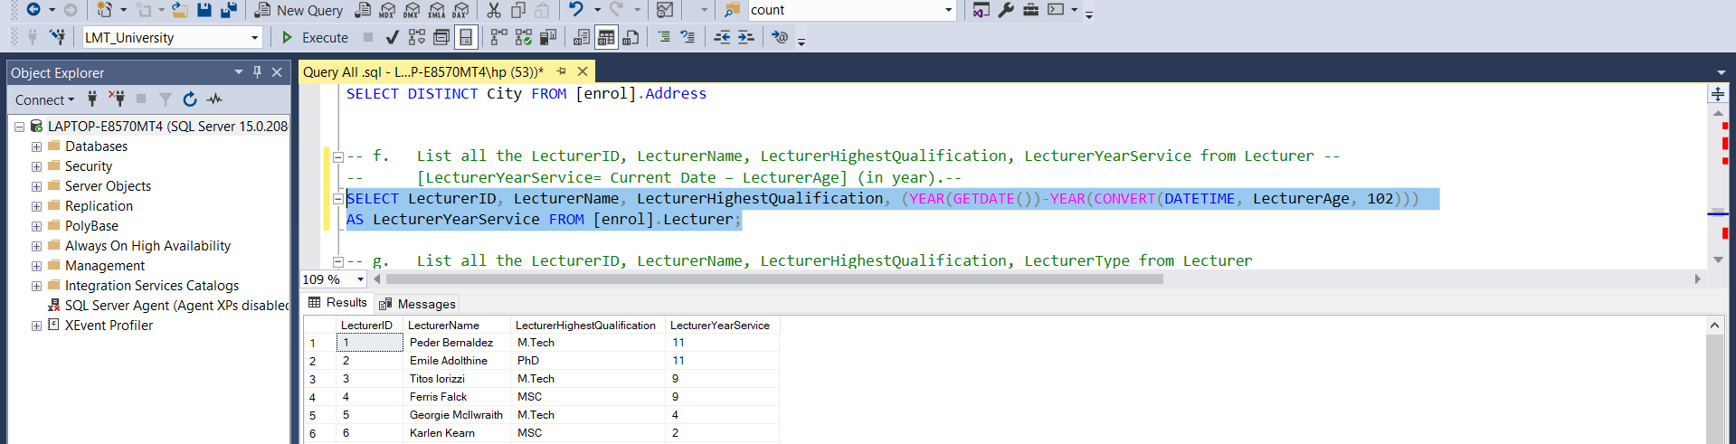

* 1. **List all the LecturerID, LecturerName, LecturerHighestQualification, LecturerType from Lecturer [LecturerType= if LecturerYearService< 5 then "Begining Level Experience" else if LecturerYearService>= 5 and LecturerYearService<10 then "Mid Level experience" else "Experienced".**

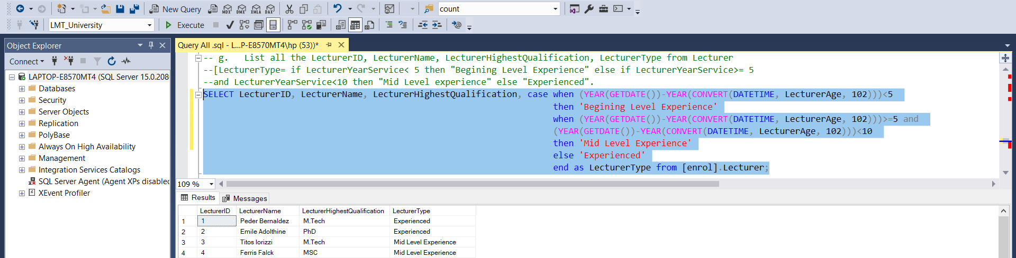

1. **Write the following Query based on the above datasets.**
   1. **Display all Student and their Department Information based on the relationship.**

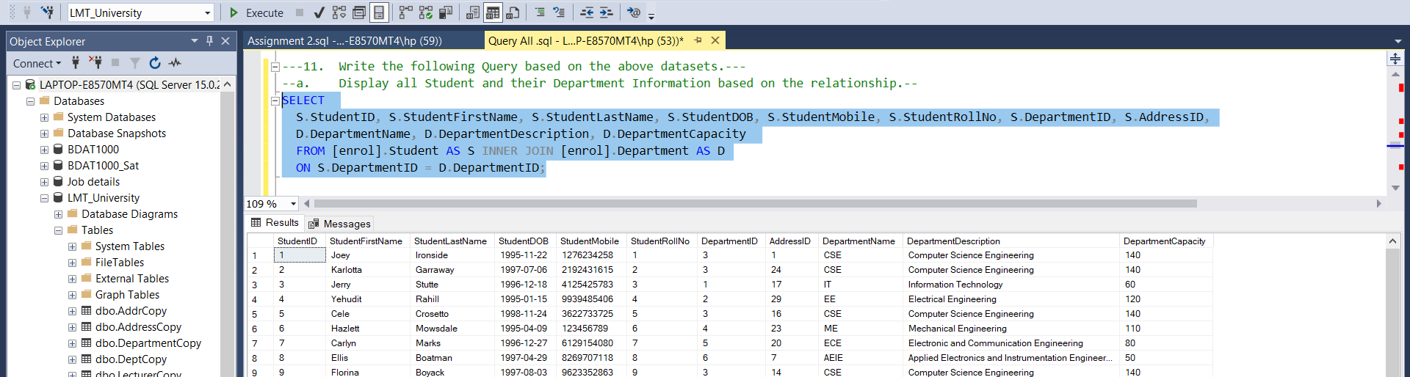

* 1. **Display all Student and their Address Information based on the relationship.**

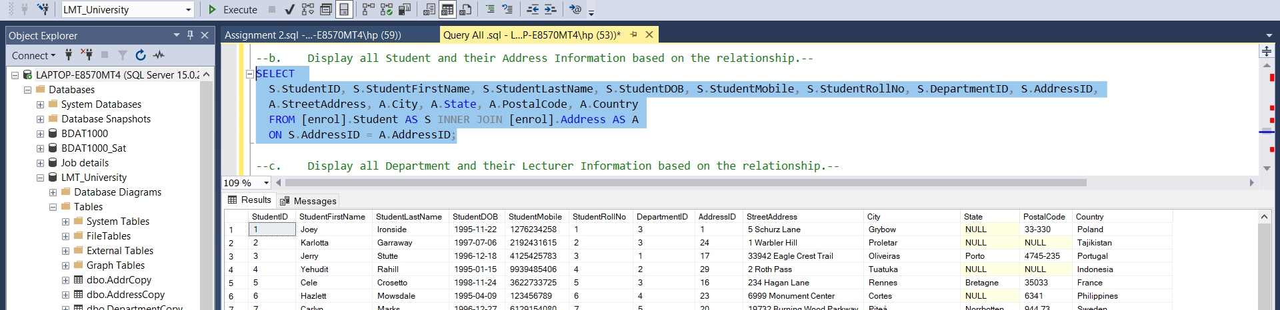

* 1. **Display all Department and their Lecturer Information based on the relationship.**

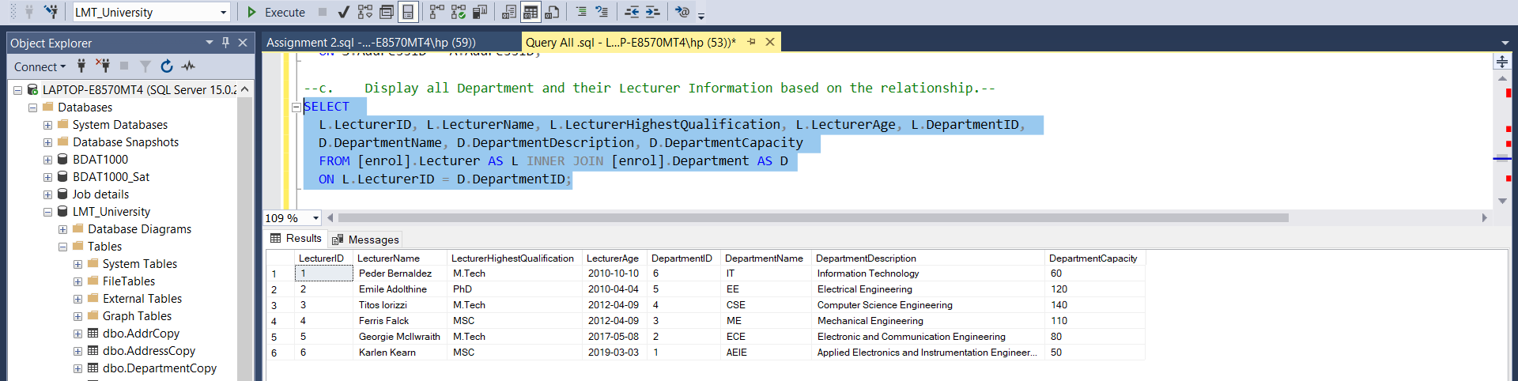

* 1. **Display all Student with their Department with Lecturer Information based on the relationship.**

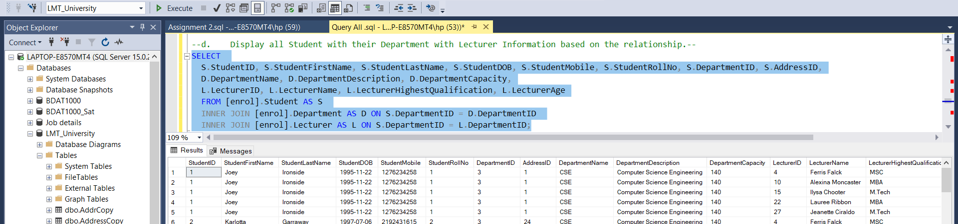

* 1. **Display all Student with their Address and Department Information based on the relationship.**

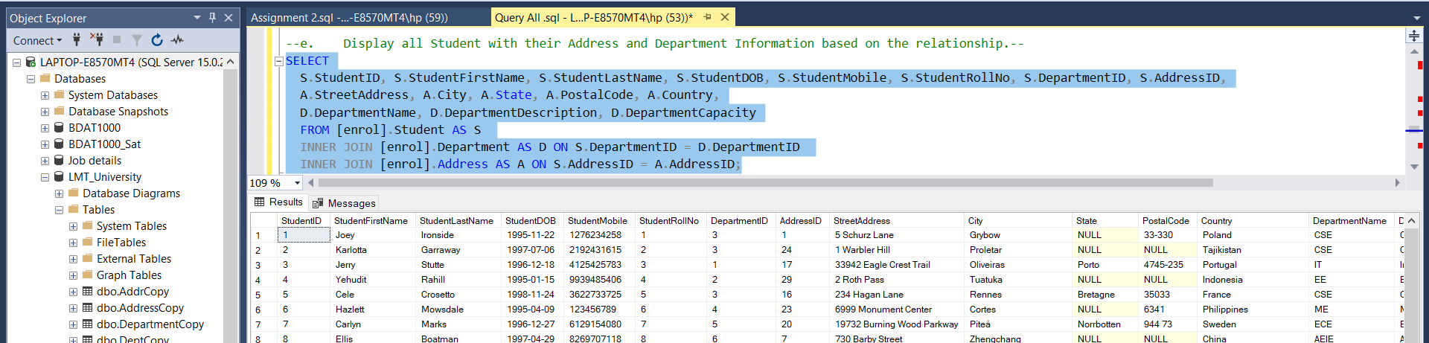

* 1. **Display all Student with Address, Department and Lecturer Information based on the relationship.**

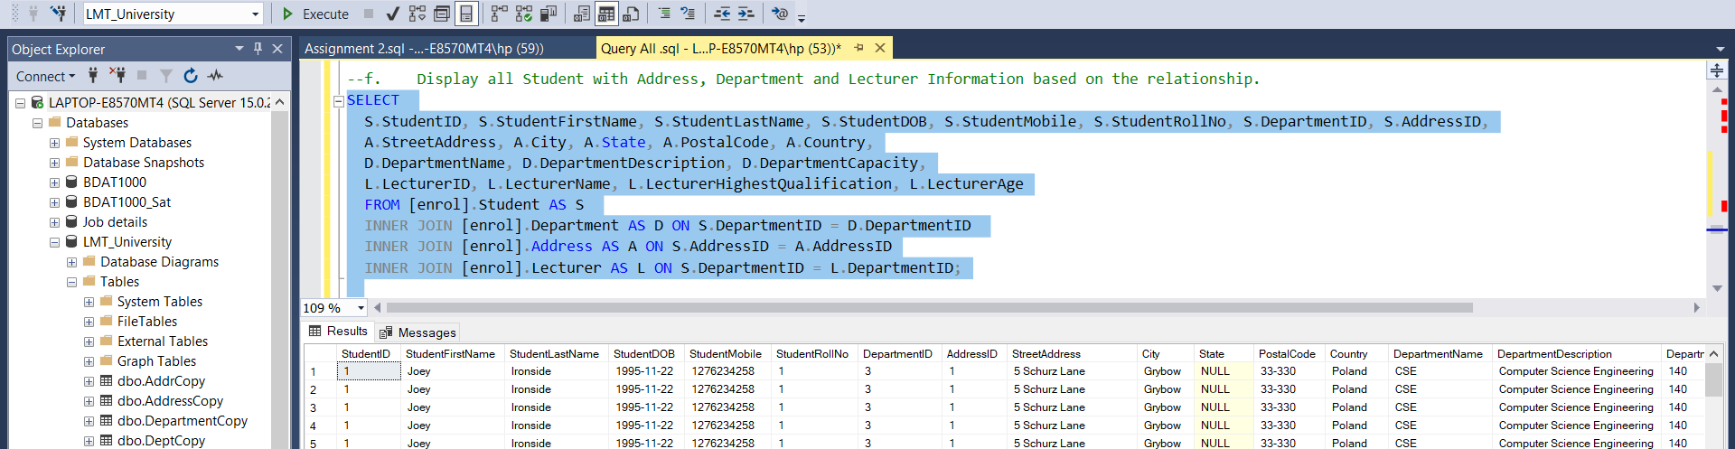

* 1. **Display all Student with Address, Department and Lecturer Information who belongs to either “ME” or “ECE” department.**

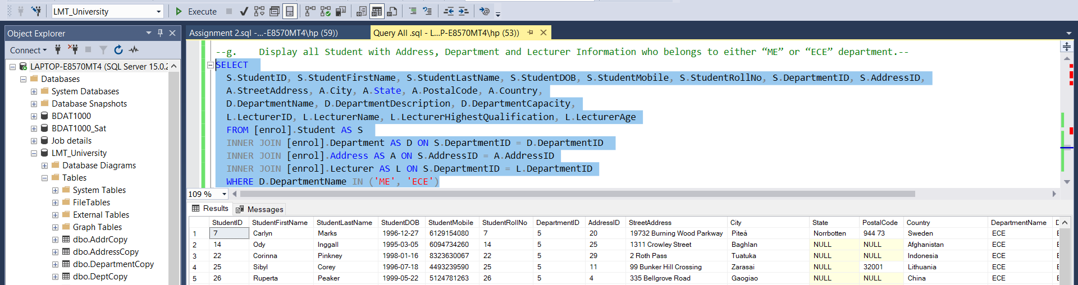

* 1. **Display Student with Department and their Lecturer information based on the LecturerHighestQualification either “MS” or “PhD”.**

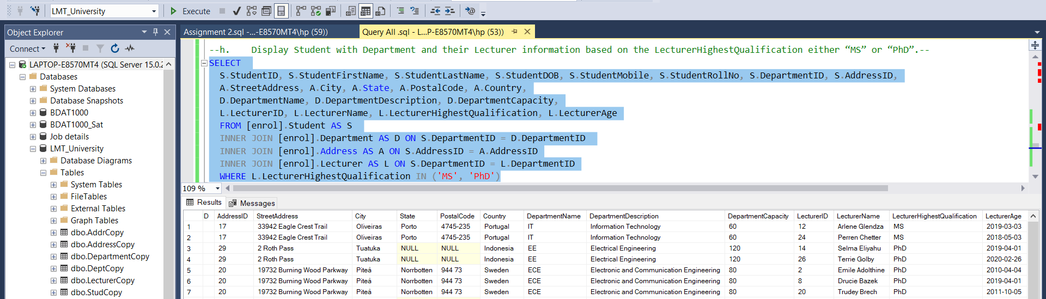

* 1. **Display Student with Department and Address Information, where student belongs to “Thailand” country.**

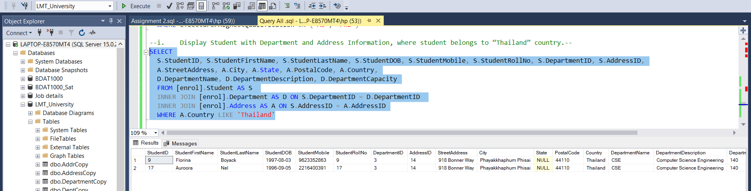

* 1. **Display Count of Student, Department wise.**

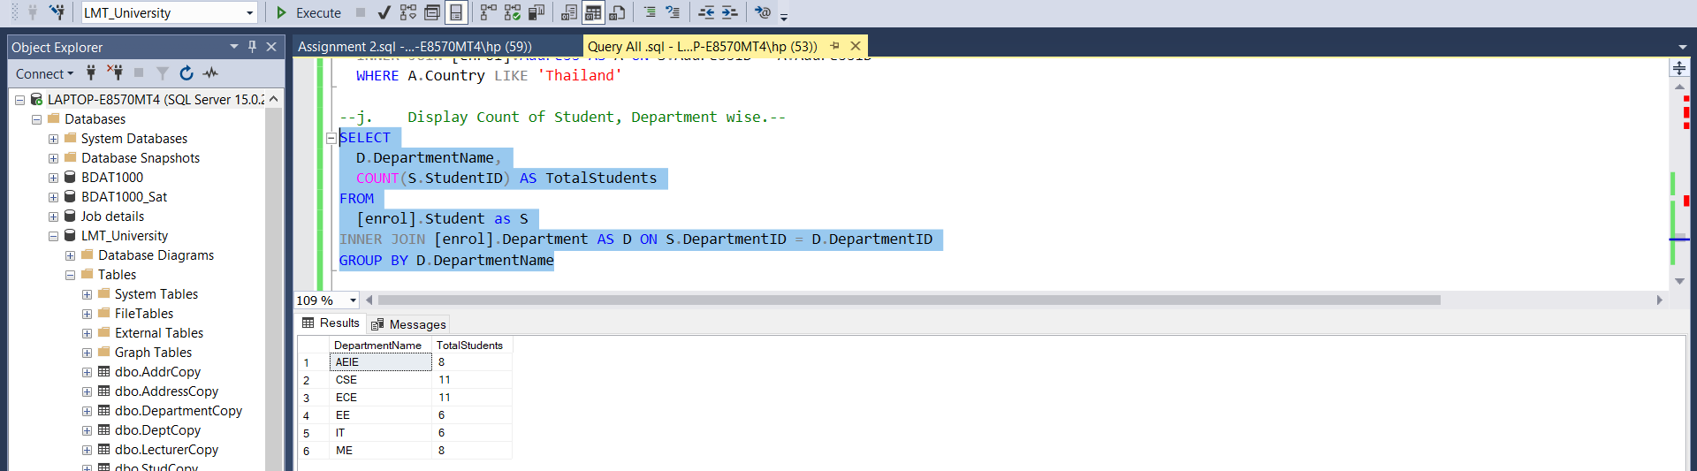

* 1. **Display Count of Lecturer, Department wise.**

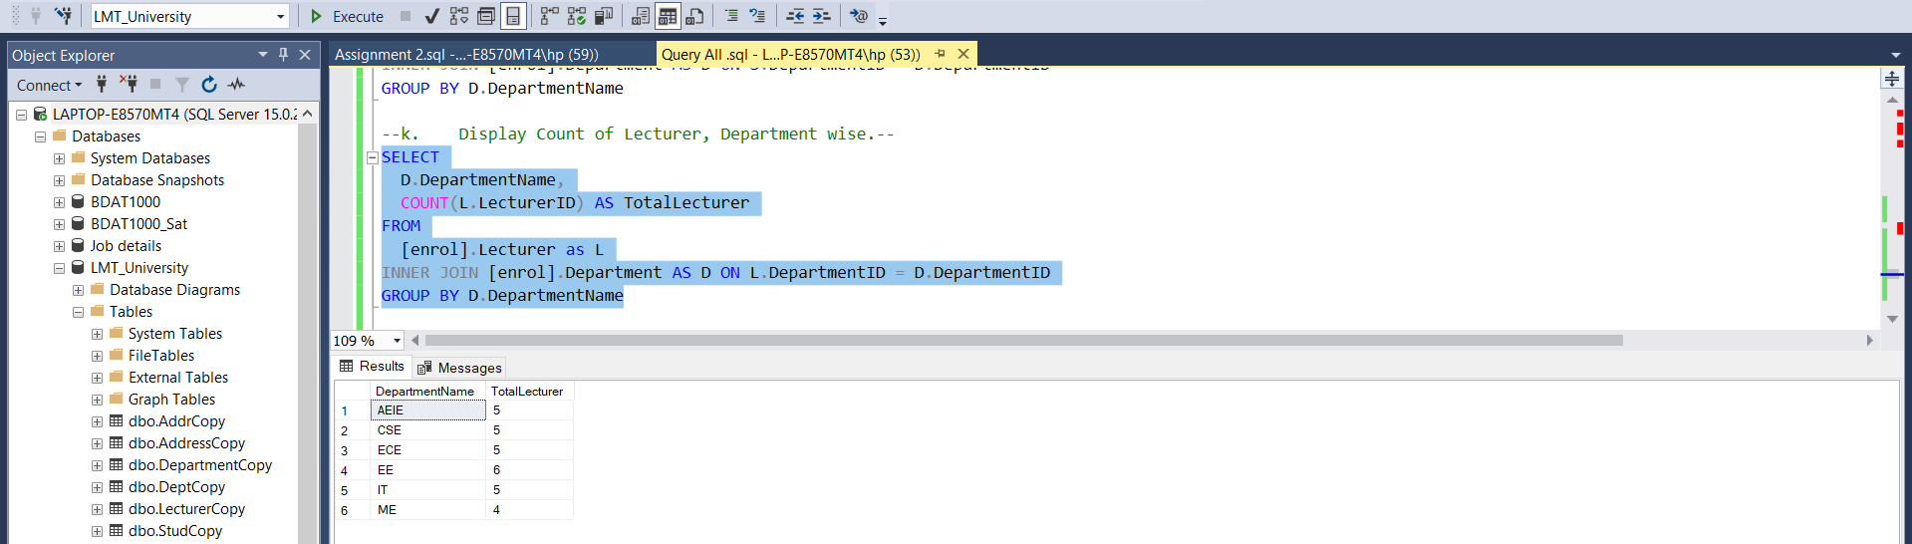

* 1. **Display Count of Student, Country wise.**

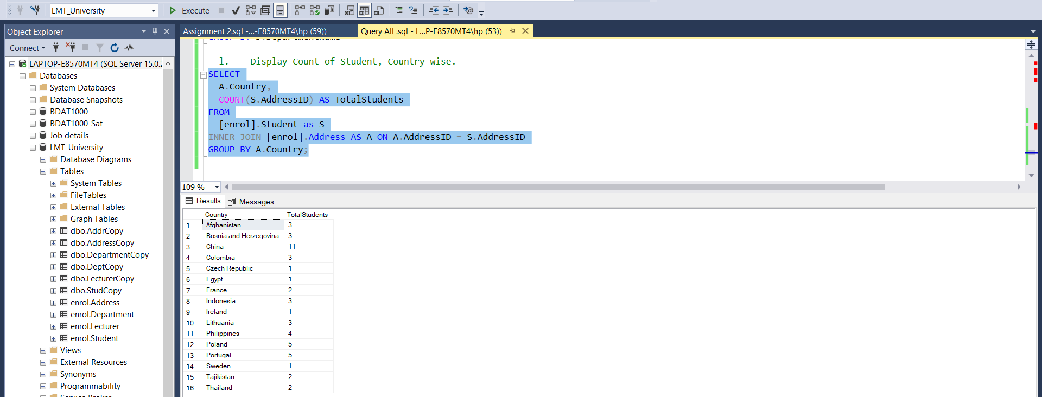

1. Write the following Query based on the above datasets.
   1. Create new table StudCopy and copy all records from Student table.
   2. Create a new table DeptCopy and copy only the schema from Department table.
   3. Create a new table DepartmentCopy and copy all records from Department table.
   4. Create a new table AddrCopy and copy only the schema from Address table.
   5. Create a new table AddrCopy (AddressCopy**)and copy all the records from Address table.
   6. Create a new table LecturerCopy and copy all the records from Lecturer table.

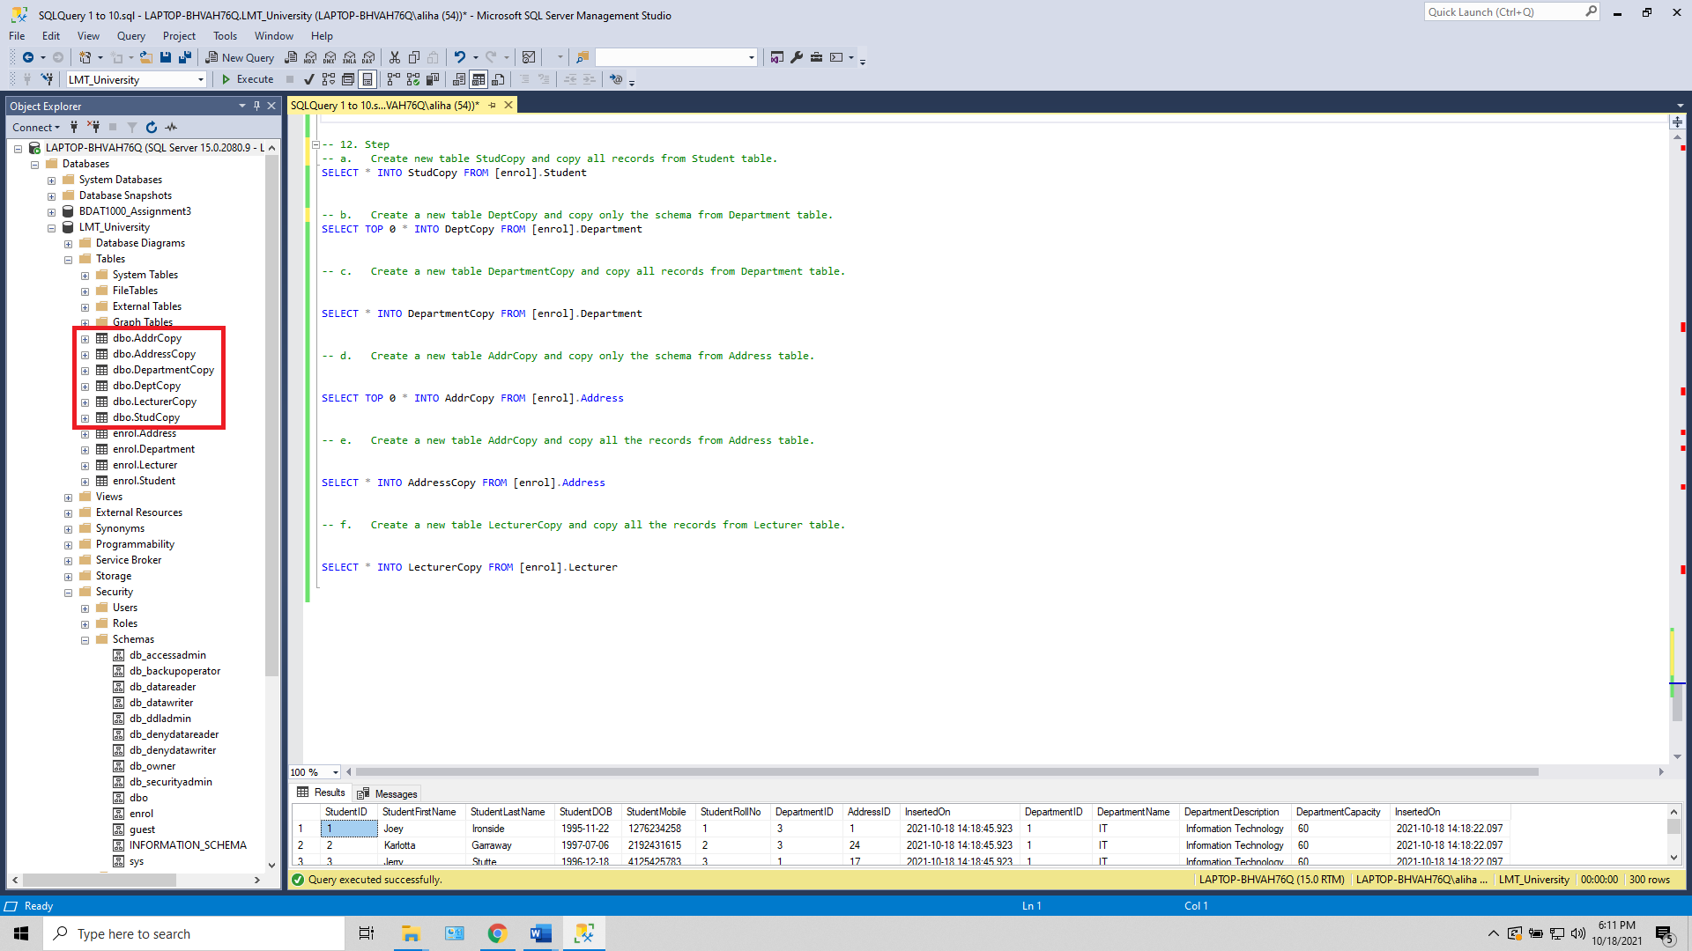

1. **Write the following Query based on the above datasets.**
   1. **Delete all the records from LecturerCopy table.**

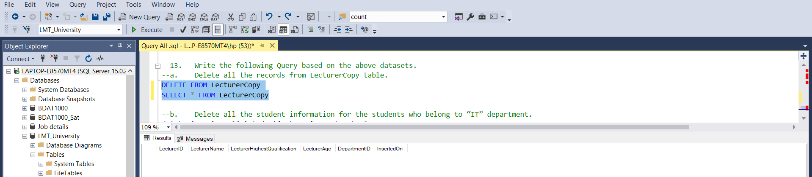

* 1. **Delete all the student information for the students who belong to “IT” department.**

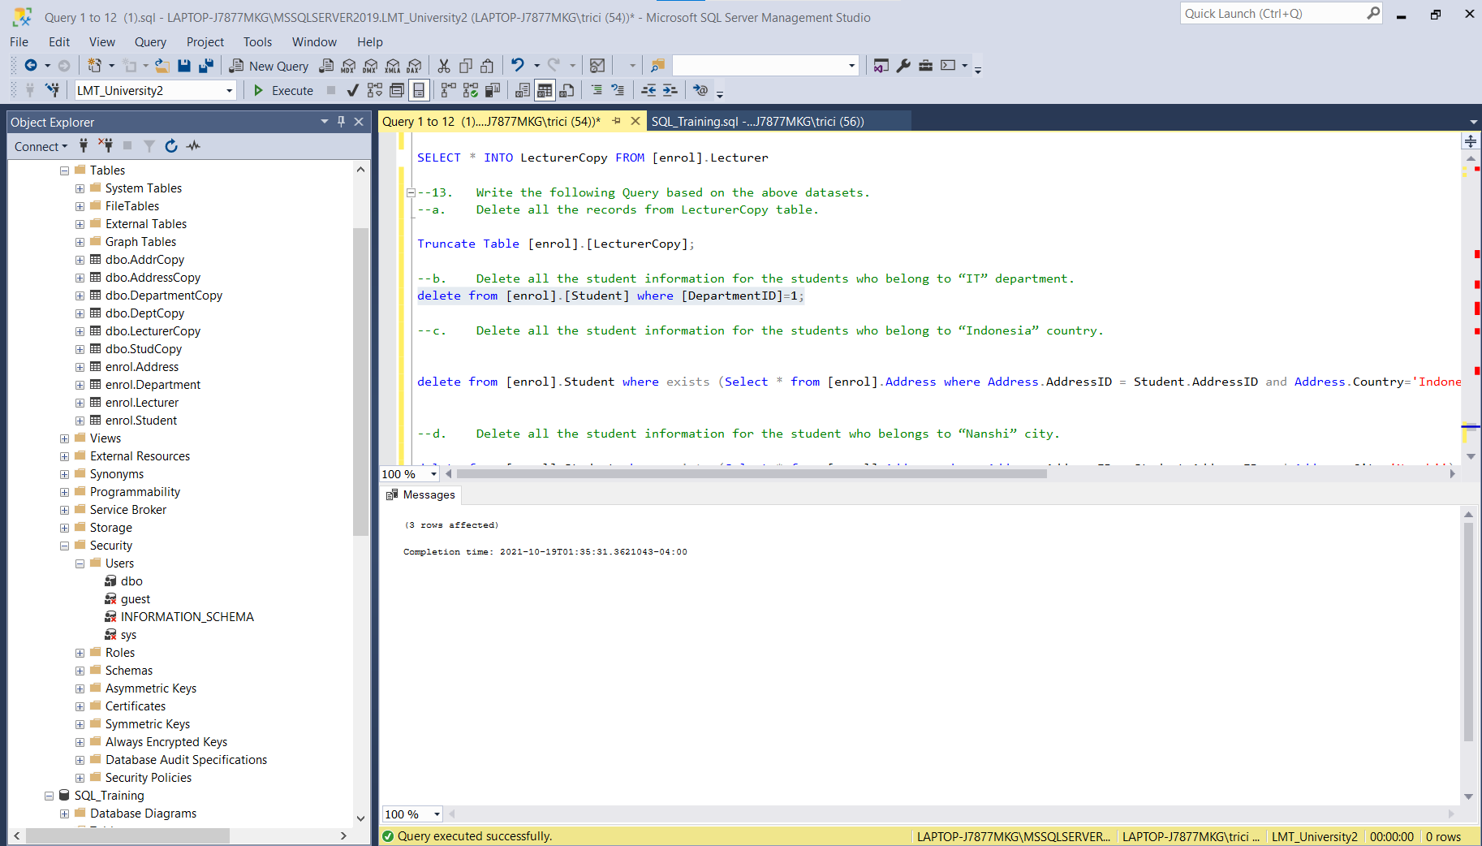

* 1. **Delete all the student information for the students who belong to “Indonesia” country.**

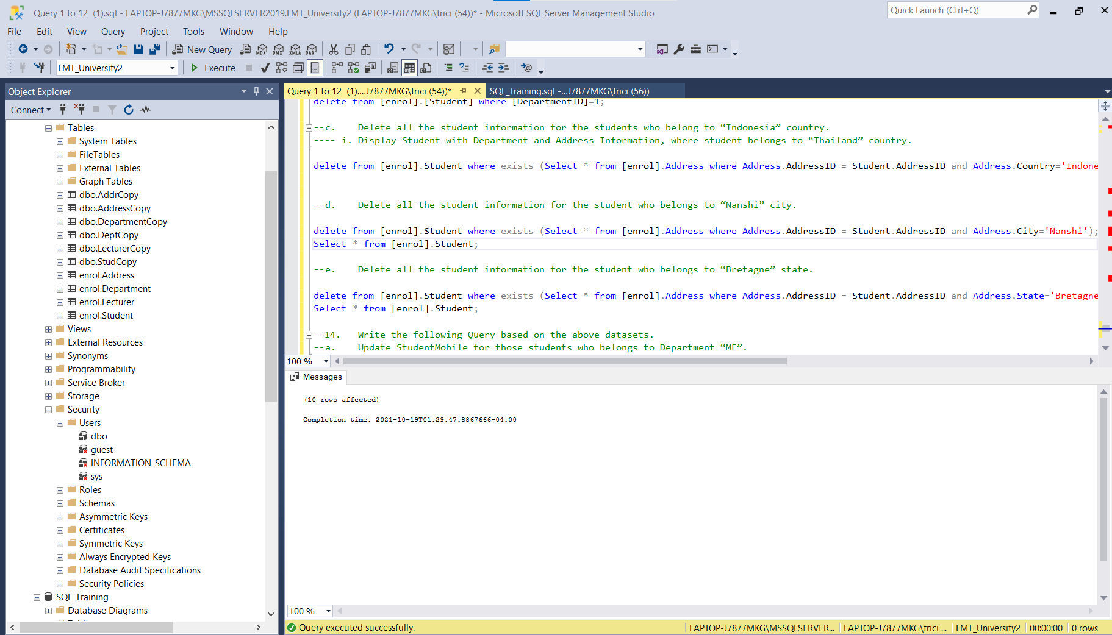

* 1. **Delete all the student information for the student who belongs to “Nanshi” city.**

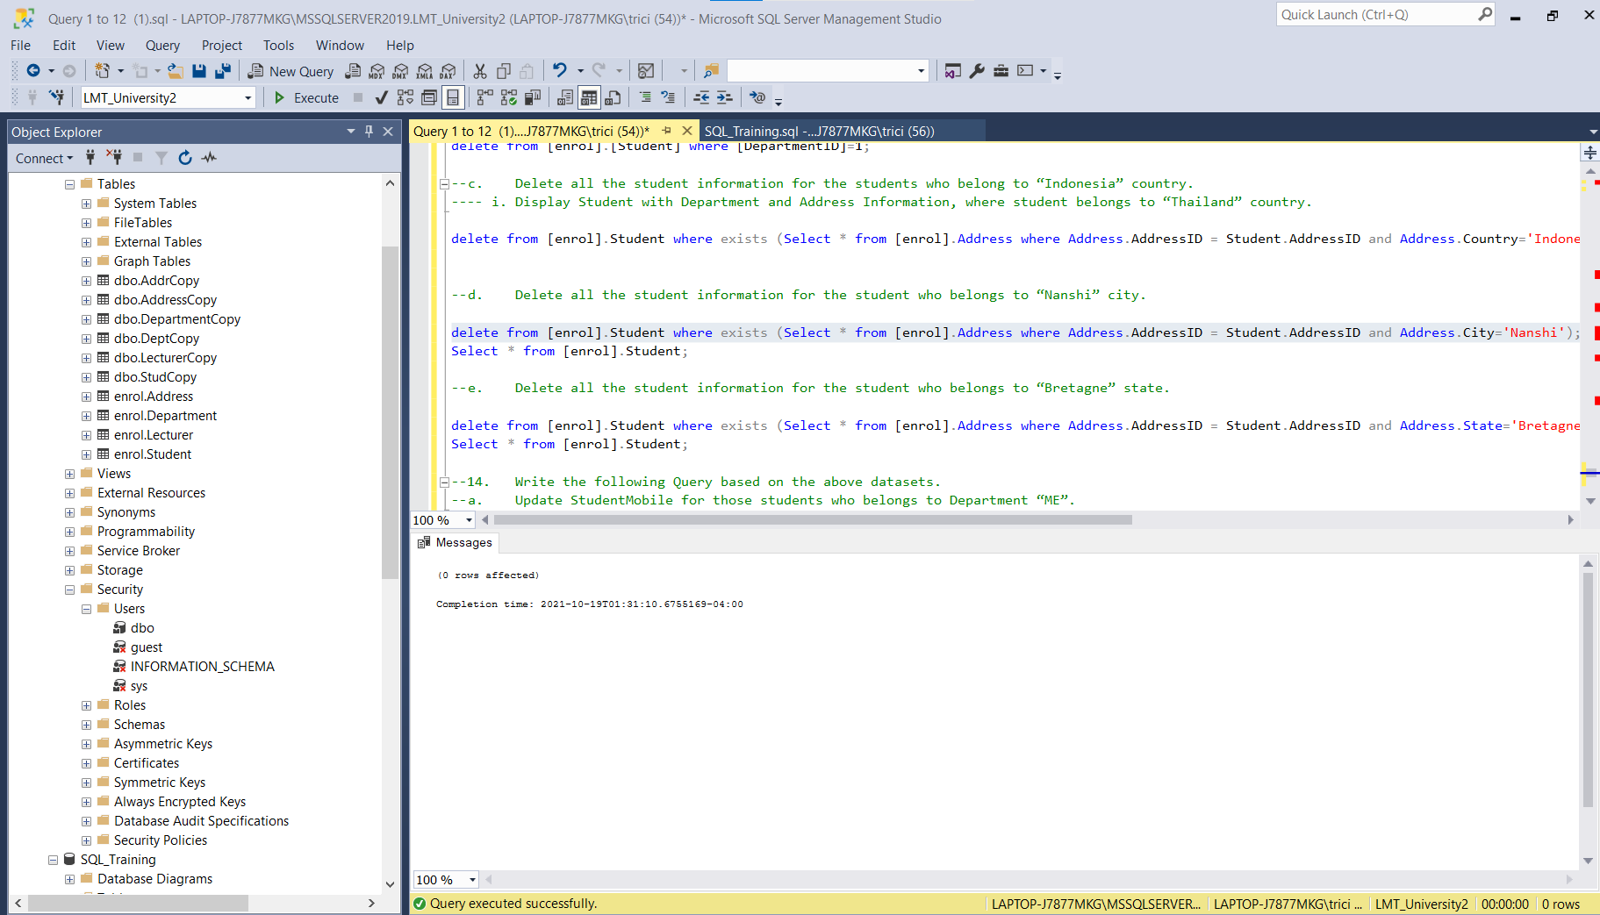

* 1. **Delete all the student information for the student who belongs to “Bretagne” state.**

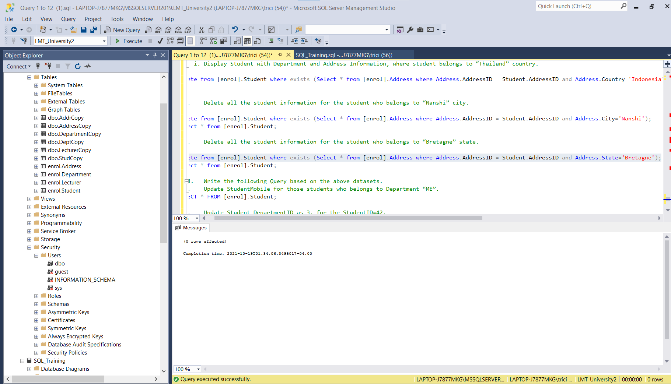

1. **Write the following Query based on the above datasets.**
   1. **Update StudentMobile for those students who belongs to Department “ME”.**

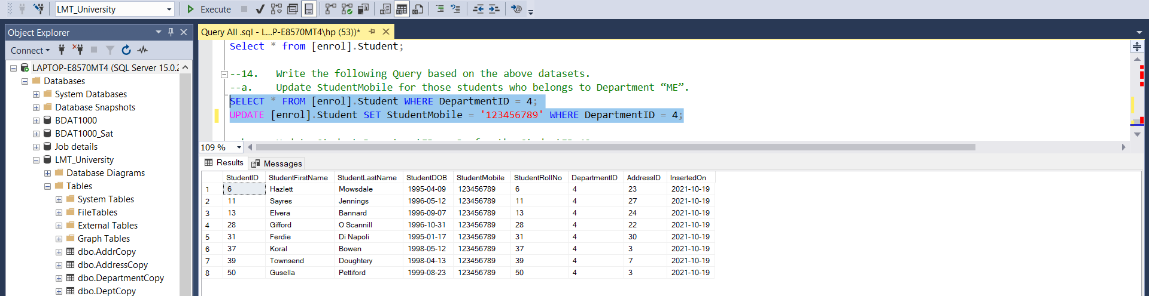

* 1. **Update Student DepartmentID as 3, for the StudentID=42.**

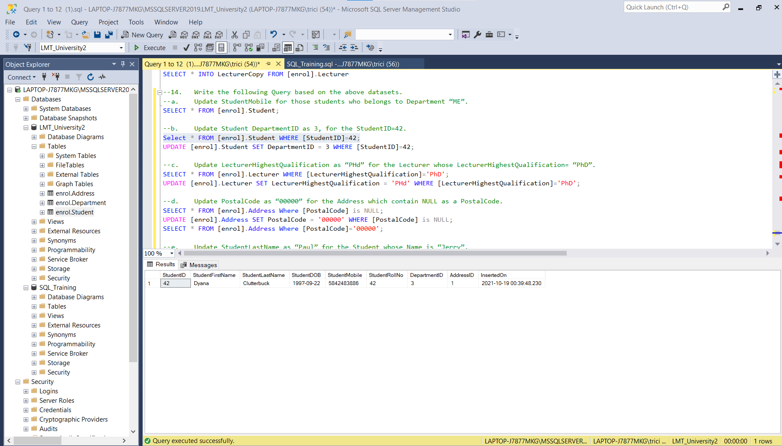

* 1. **Update LecturerHighestQualification as “PHd” for the Lecturer whose LecturerHighestQualification= “PhD”.**

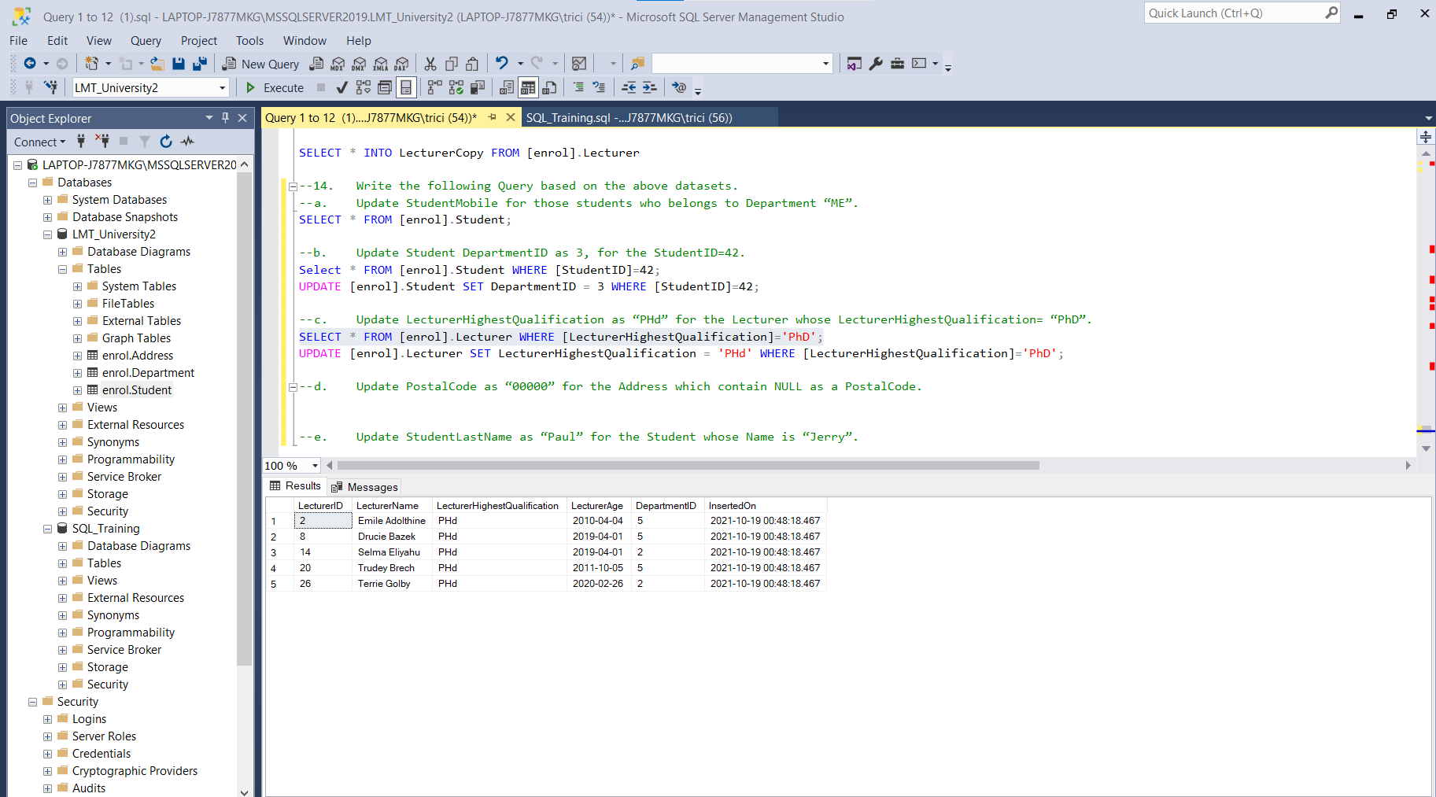

* 1. **Update PostalCode as “00000” for the Address which contain NULL as a PostalCode.**

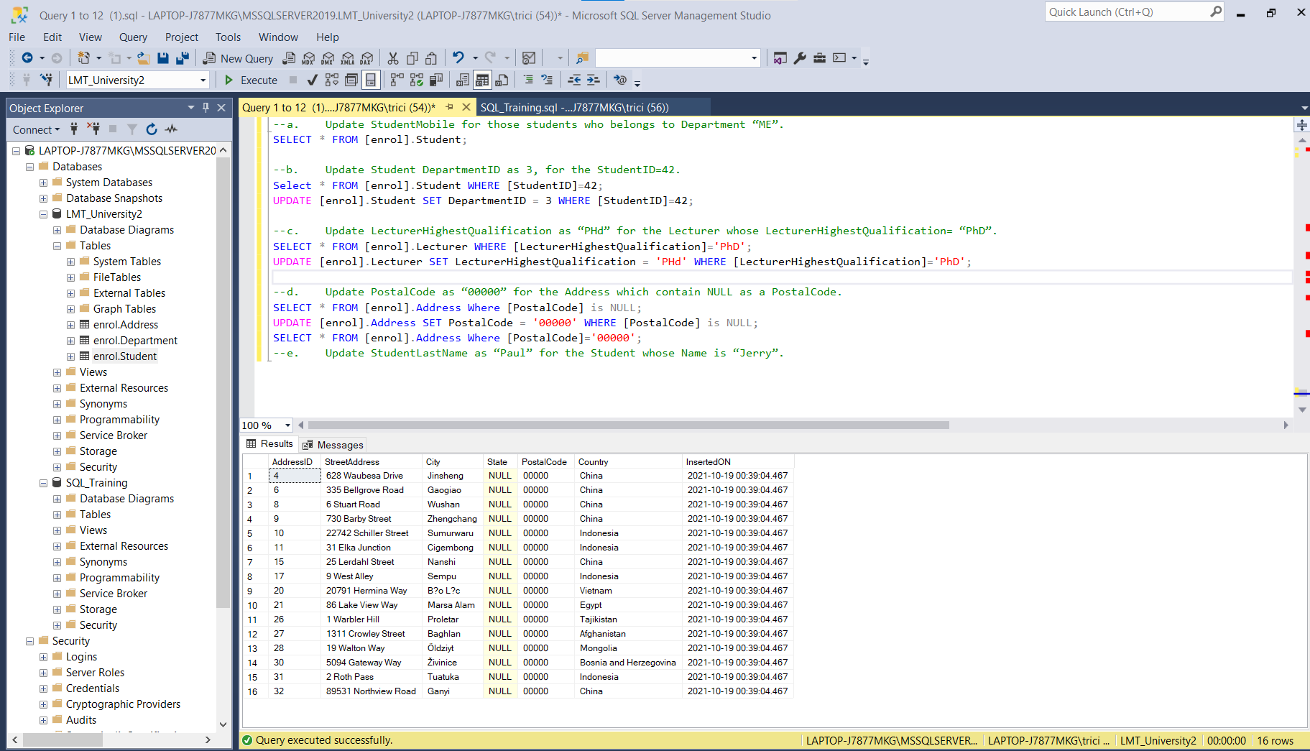

* 1. **Update StudentLastName as “Paul” for the Student whose Name is “Jerry”.**

